

UK Electoral Web Application Report
Assessment 2: Web Application
Module Coordinator: Ed

Date of submission: 19/01/2024
Number of words: 2000

How the database system was implemented:
The database was created in mySQL workbench, I created SQL scripts to create 5 tables, candidates, constituencies, parties, votes, and results. The results table is empty by default because it is meant to store the results of the calculations, the other tables just have the data imported into it via the Table data import wizard (Macarty, 2020) and importing the data that fits the headers to ensure the database is in 3NF. Then I implemented the database with Python Flask and SQLAlchemy, I created a models.py (DigitalOcean, 2022) to communicate with the database and then created a fetch_data() function to query each table and import and return the values so I can manipulate the data.
Link to Database Webapplication folder: https://bathspaonline-my.sharepoint.com/:f:/g/personal/archie_cook21_bathspa_ac_uk/EmwIMd-q7atLkfjKfHSyNnsB_jID4ood0Fv14H3xD8d9AA

How the calculations for the results were implemented into the program:
The calculations are done in various Python files and imported into app.py which uses flask, SQLAlchemy and HTML, CSS & Javascript (DigitalOcean, 2023) to grab the data for mySQL server database on localhost and selects the schema, then data is fetched “from models import candidates, constituencies, parties, votes, results.” Which imports from the models file the class for each model which contains columns containing data for each header (GeeksforGeeks, 2023c) (SQLAlchemy, 2010)

Snippets and annotations of SQL and calculation program:
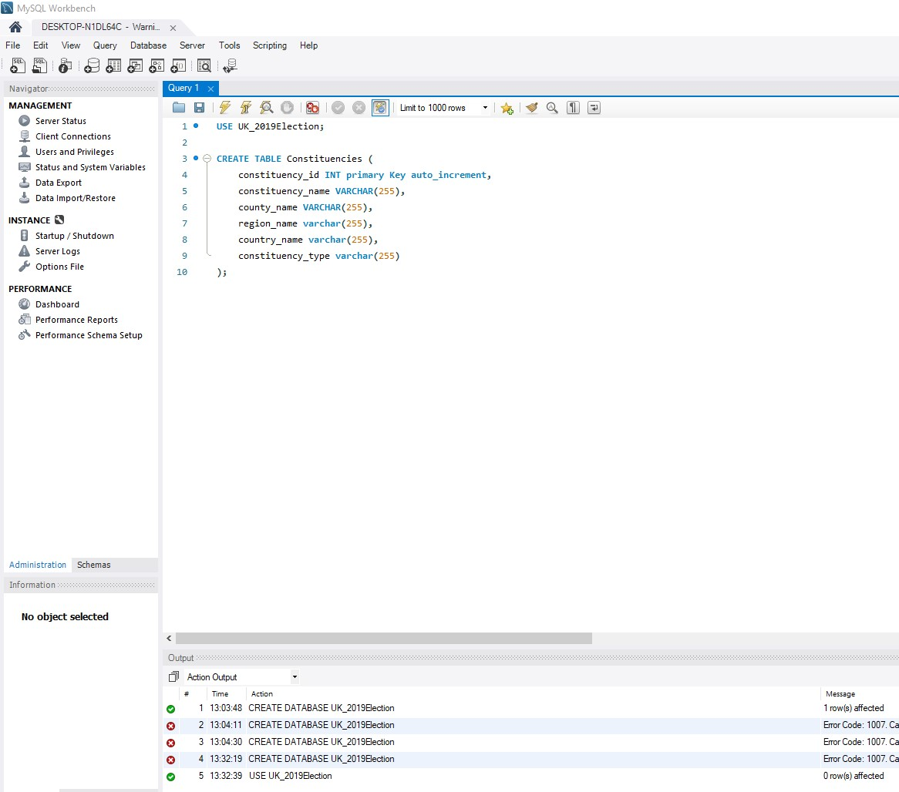
Creating tables for SQL database in MySQL workbench starting off with constituencies. (MySQL, 2024)
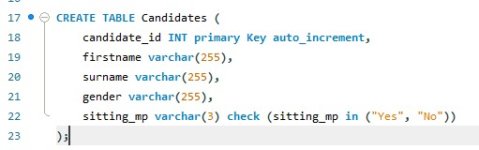
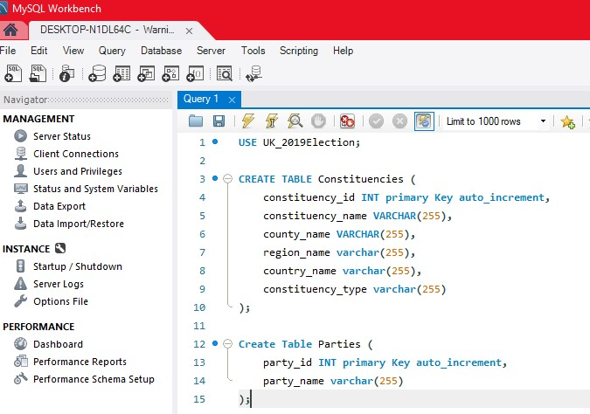
Creating parties and candidates tables then votes below.
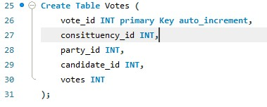
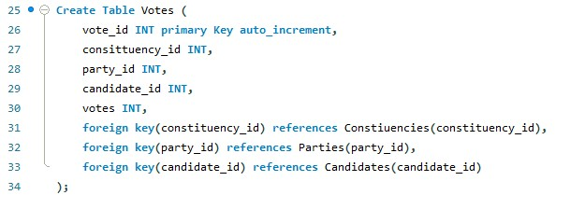
Then run the script.
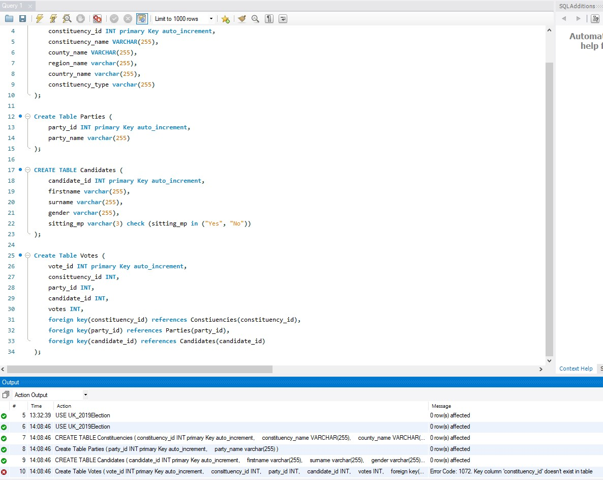
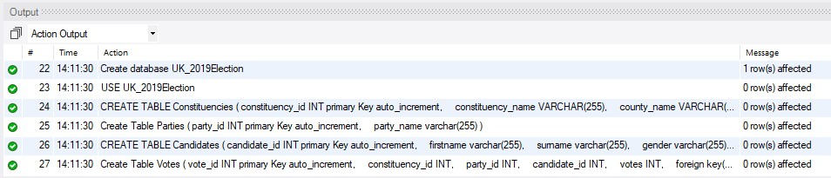
Then I needed to import the data using Table Data.
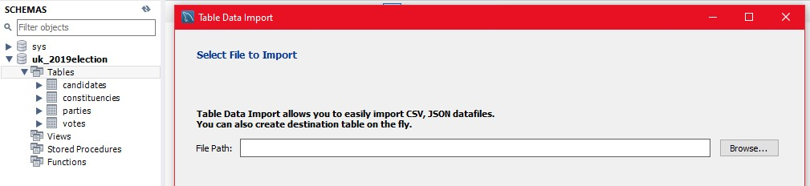
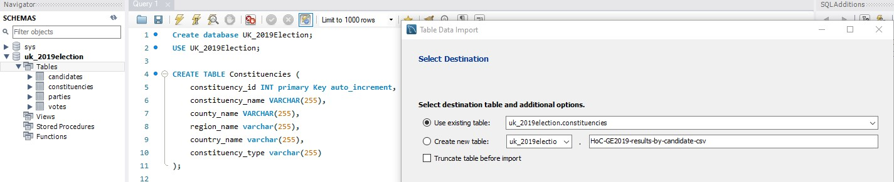
Then select the data that needs to be imported for each table accordingly the one below is for the constituencies table.
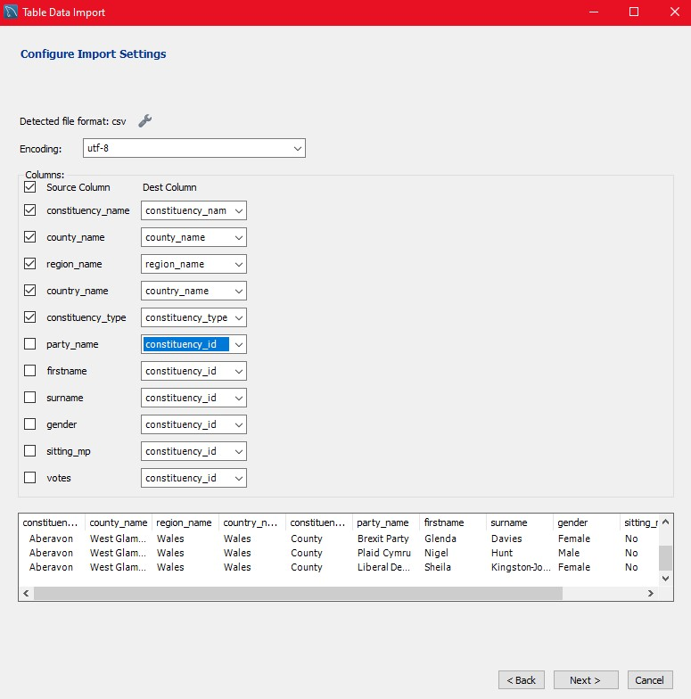
Then test that data has been imported and repeat the process till all tables are filled with data. (Macarty, 2020)
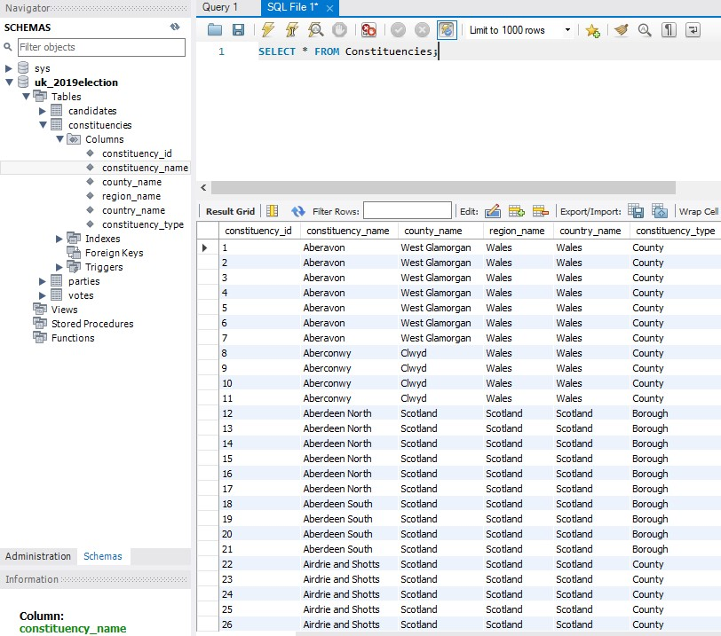
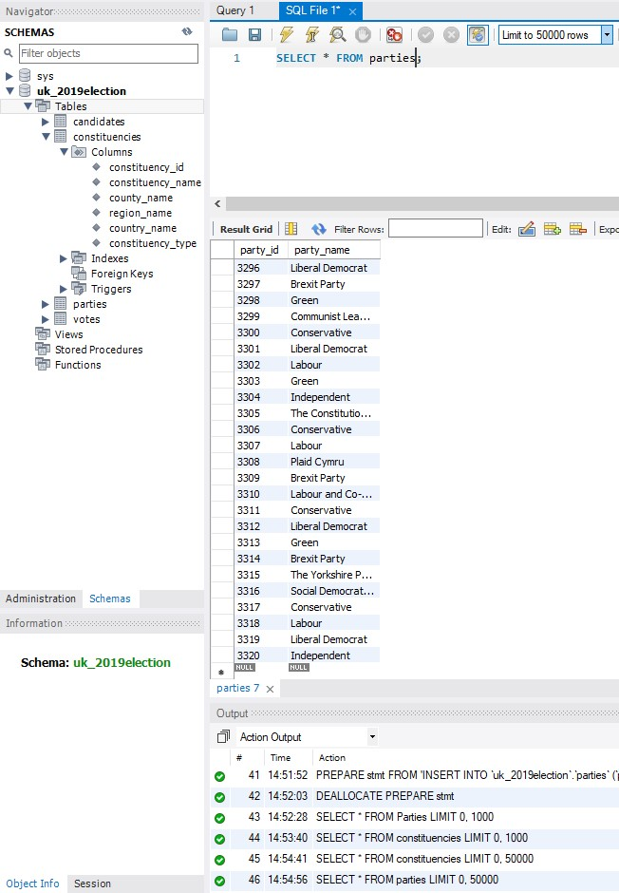
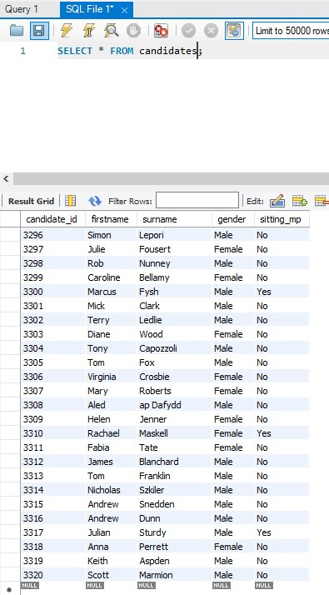
Importing votes had a bit of issues; the foreign keys had a value of null.
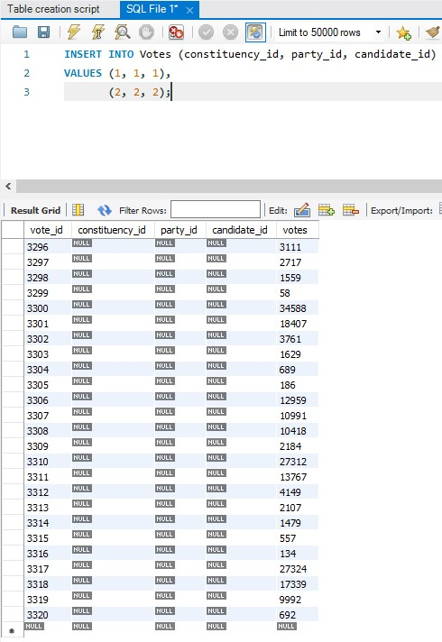
So I came up with a makeshift solution
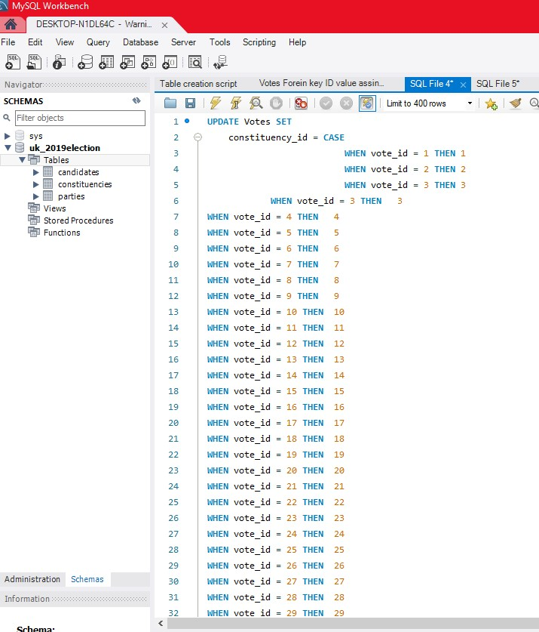
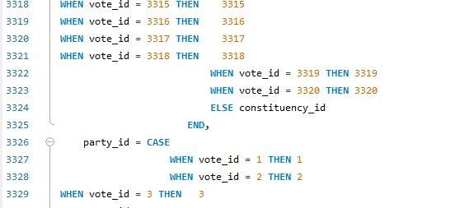
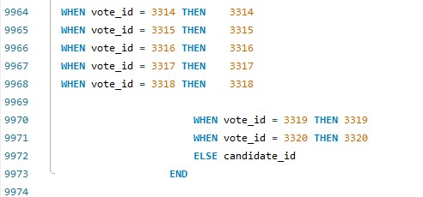
This then updated the tables to have all 3 other foreign key ids be the same as the vote id which will be needed later for calculations.
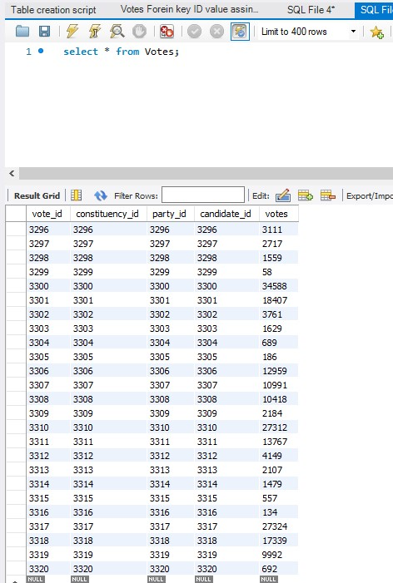
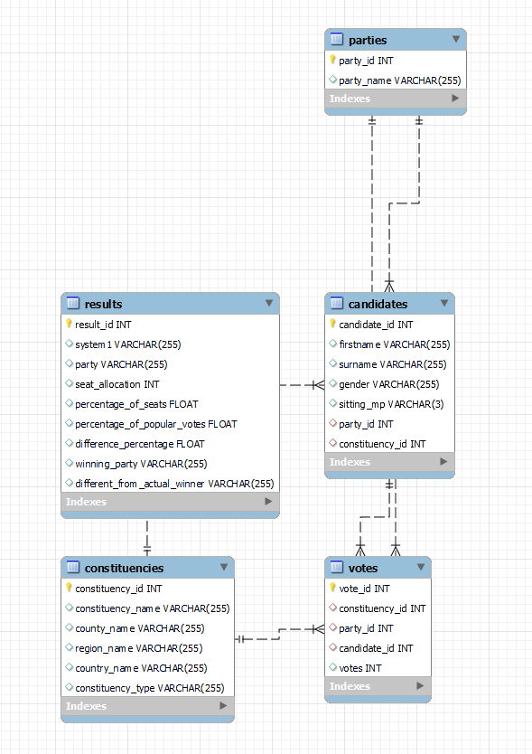
Then I needed to create a python virtual environment to start on the calculations which then goes to the website.
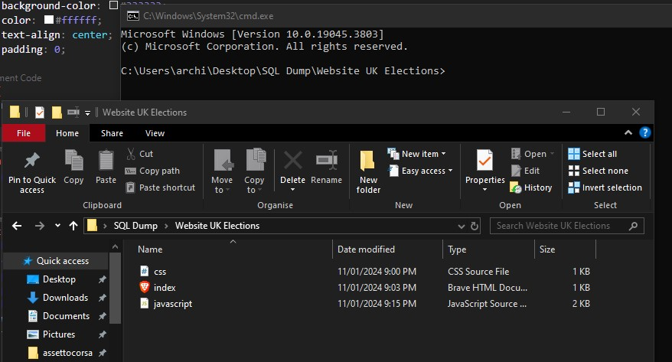
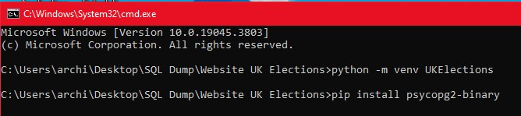
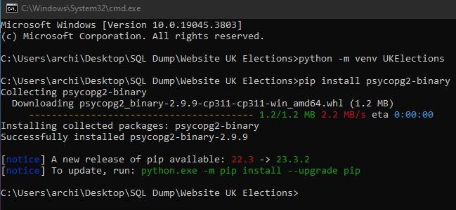
The error below had to do with the permissions for the folder so I gave full system privileges to the file.
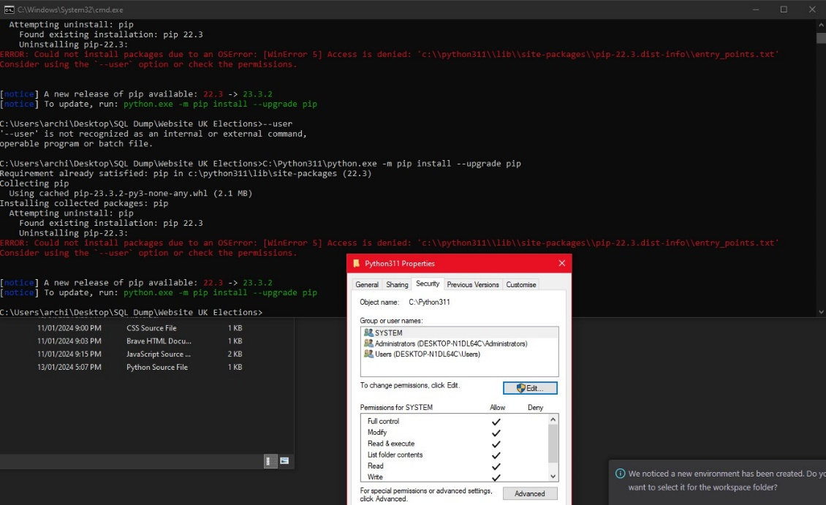

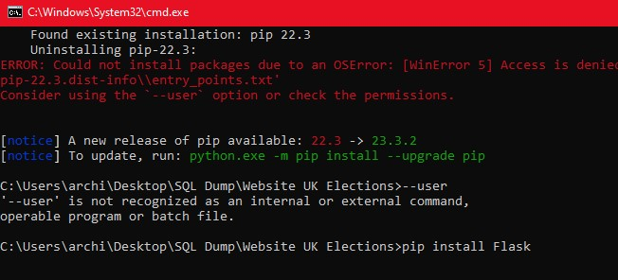
Needed to update pip.
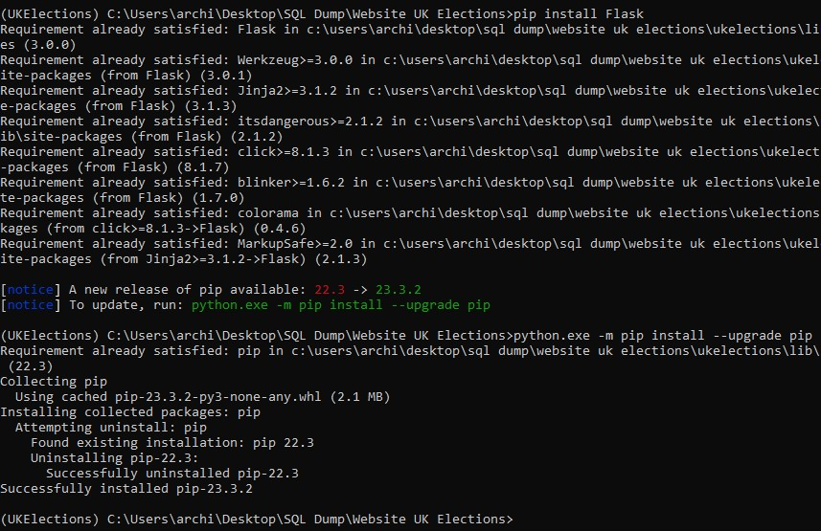
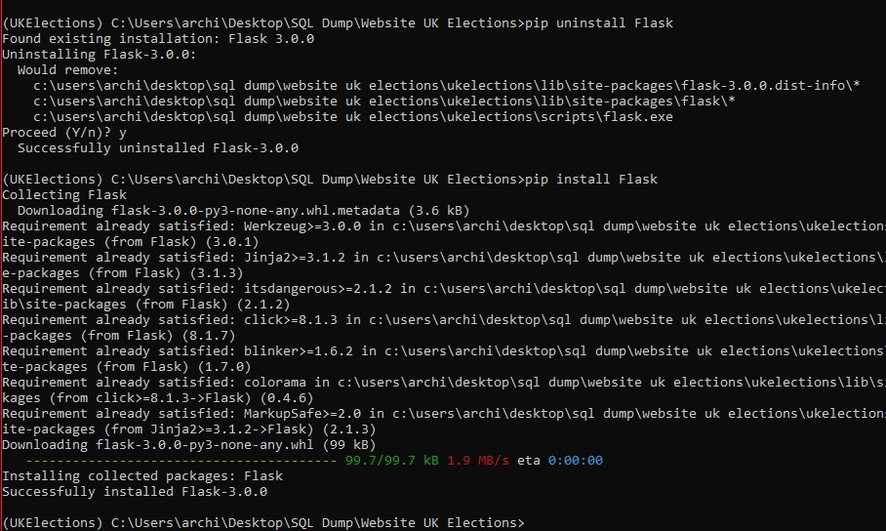
Installed mySQL connector. (w3schools, 2019)
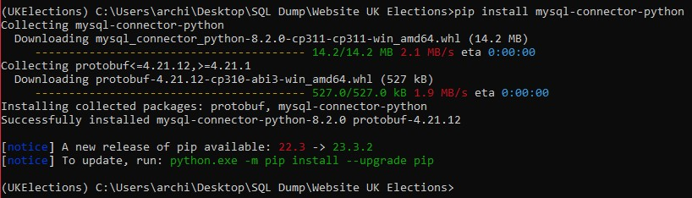

Then I redid it all and started on the calculations and initiating a Flask application. (GeeksforGeeks, 2023a)
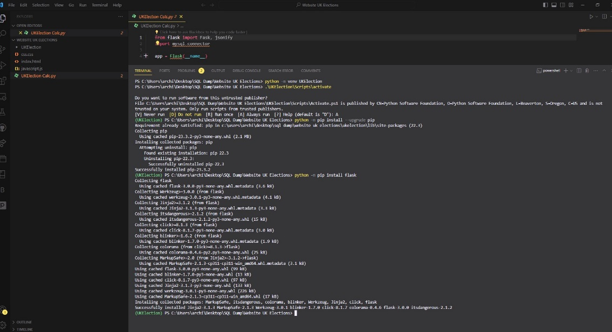
Testing flask with hello to the console.
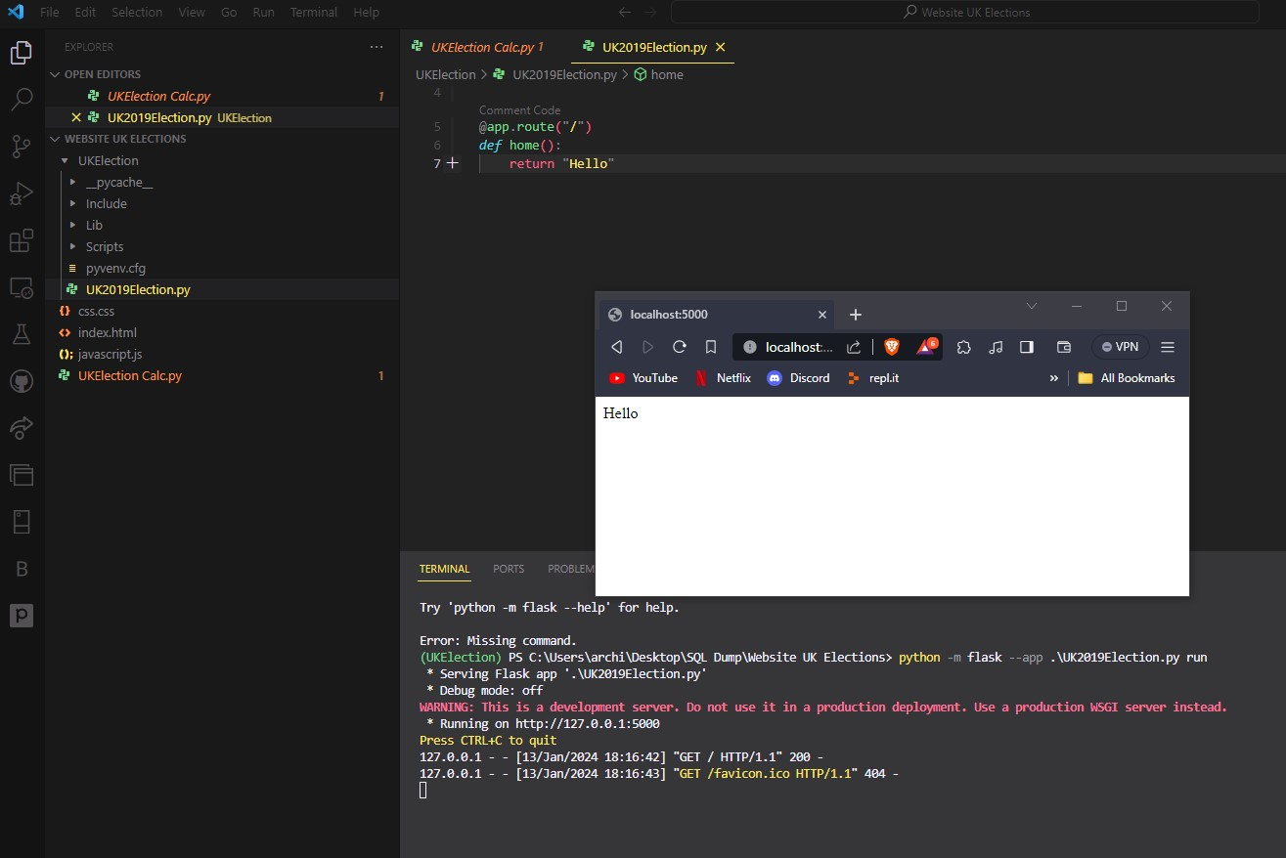
Then I connected the Flask to the HTML Index and had an error which I fixed by creating a templates folder (GeeksforGeeks, 2021):
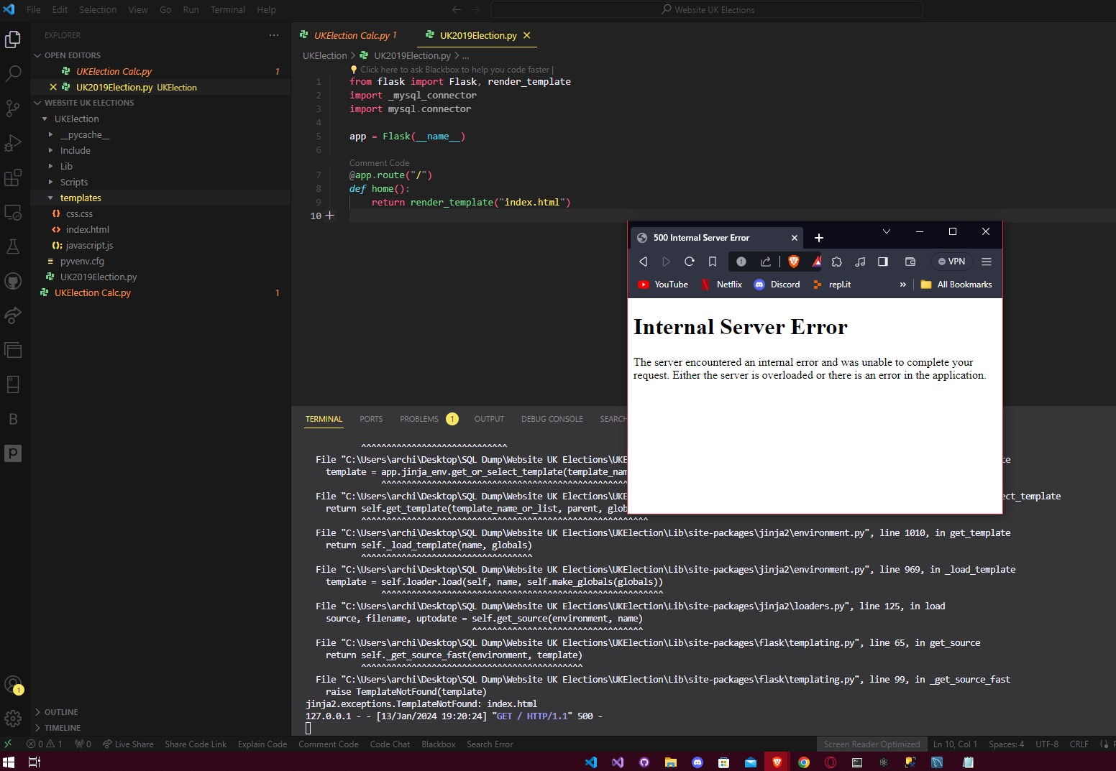
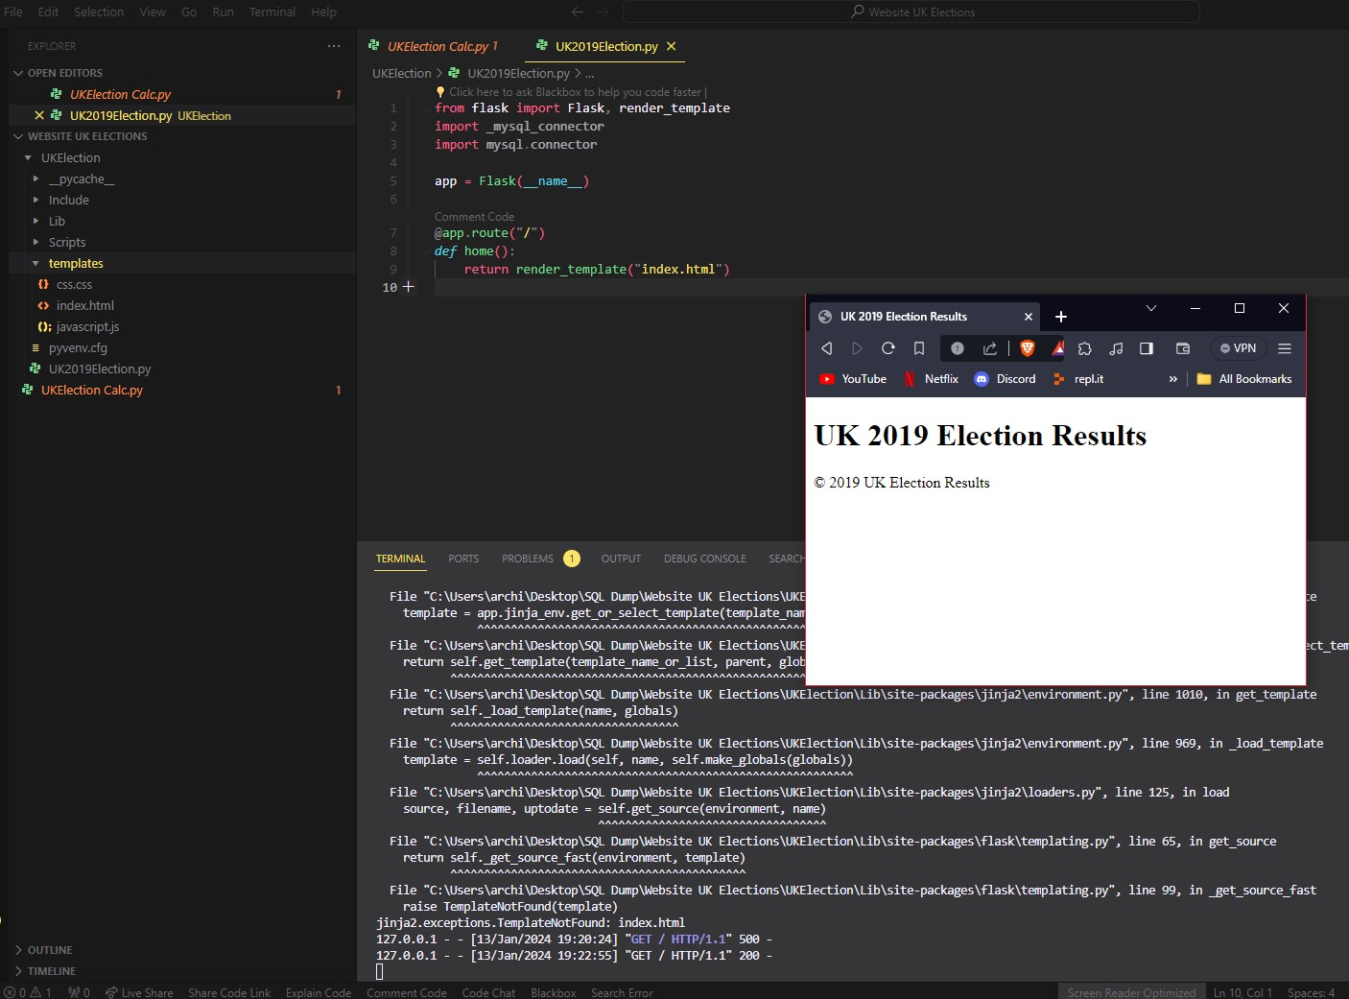
Then I needed to install SQLAlchemy as it’s a Python SQL toolkit and object-relational mapper. (SQLAlchemy, 2018)
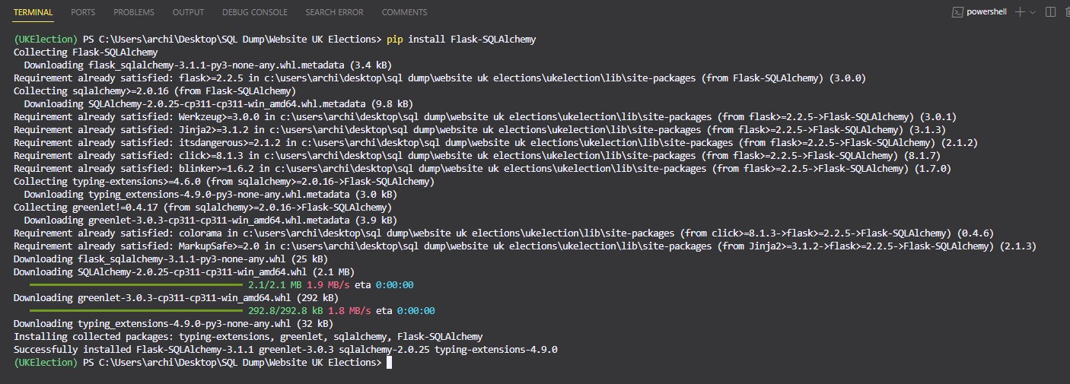
Then I needed to connect the database to the python using SQLAlchemy database uri. (SQLAlchemy, 2024d)

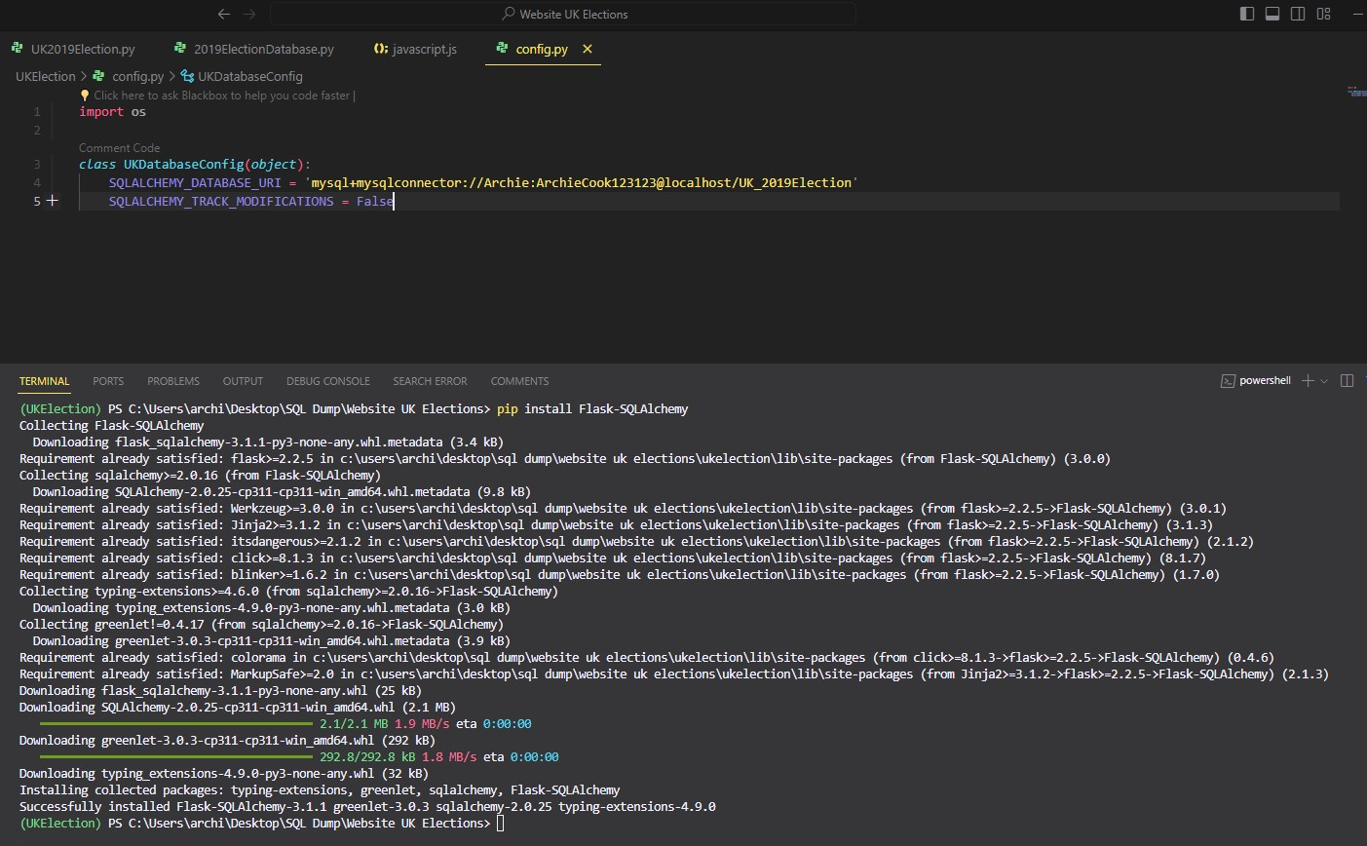
Then I realized that I needed to add foreign keys to the candidates table and fill the IDs with data corresponding to their IDs in the other tables. (WilliamDAssafMSFT, 2023)
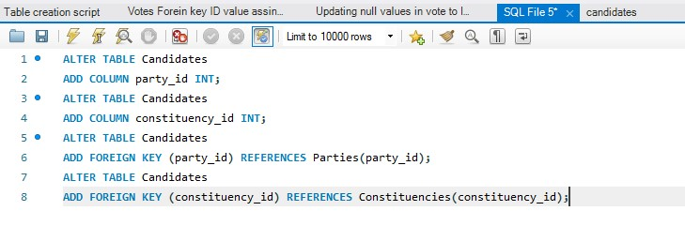
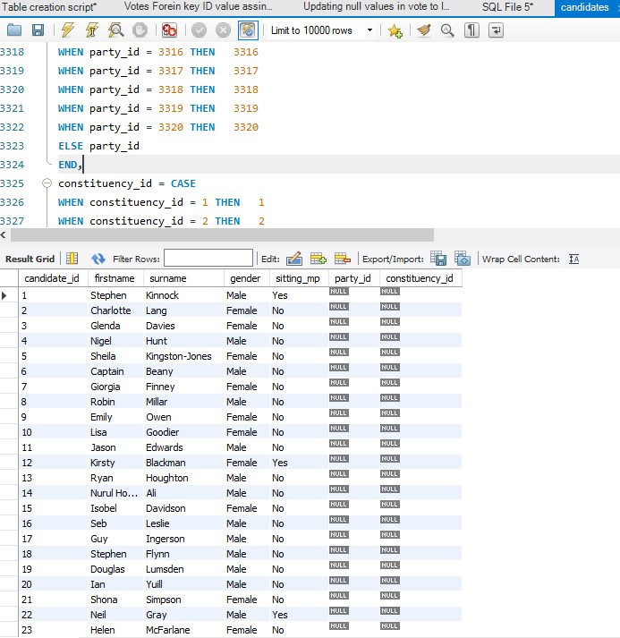
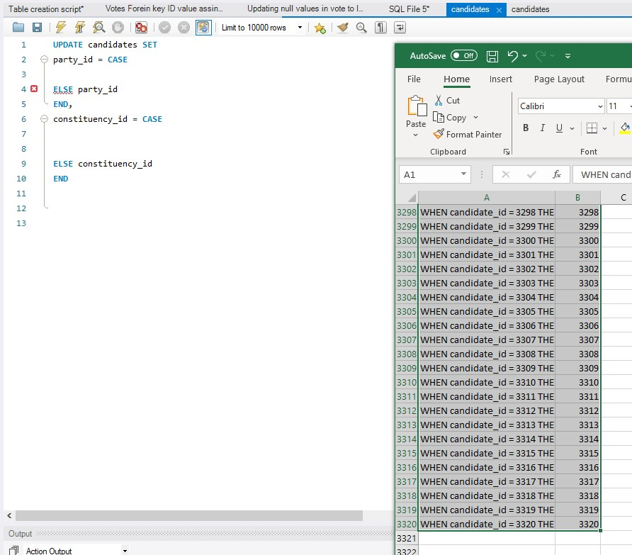
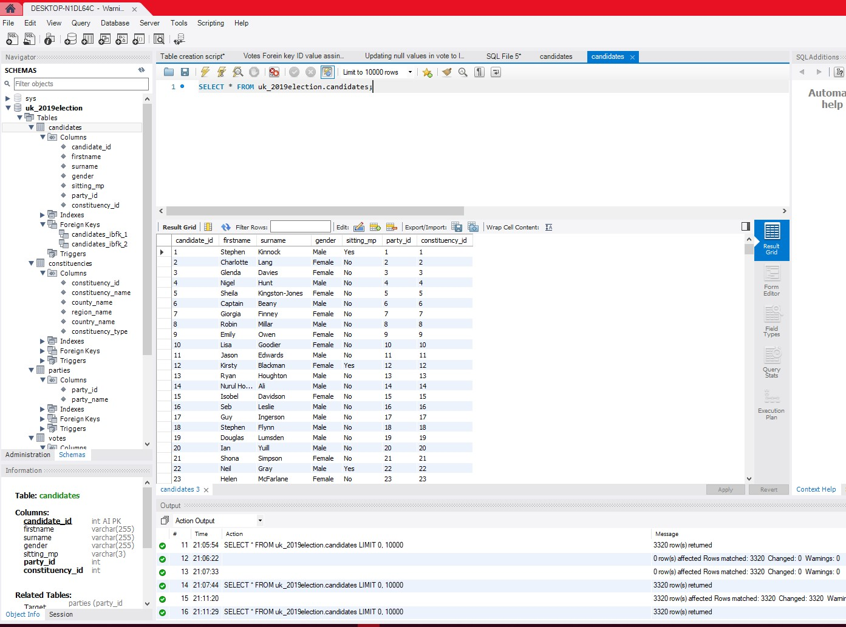
This is the models.py which defines the models; models define what data elements and rows of the database will contain. (GeeksforGeeks, 2023a) My model contains candidates, votes, parties, constituencies, and results. Results is by default empty and used to store data after the calculations for each system.
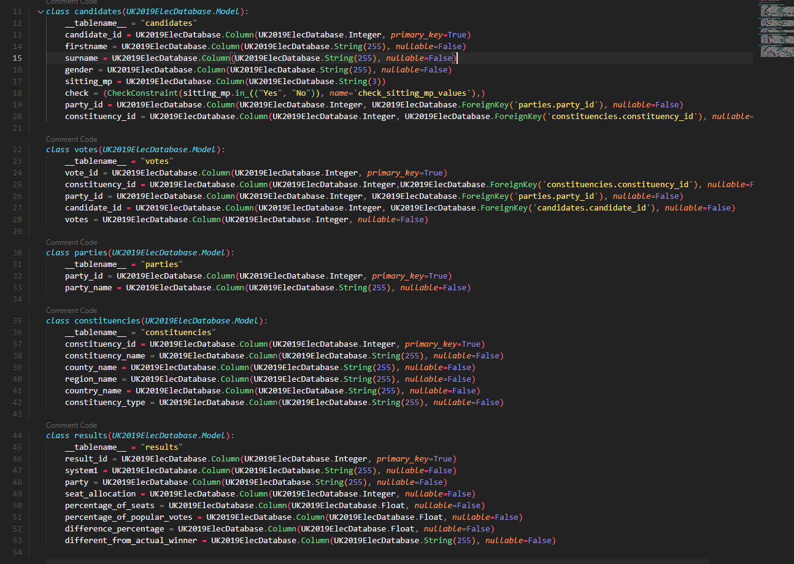
Then I created empty functions in a Python script to store the calculations. (Dyouri, 2020)
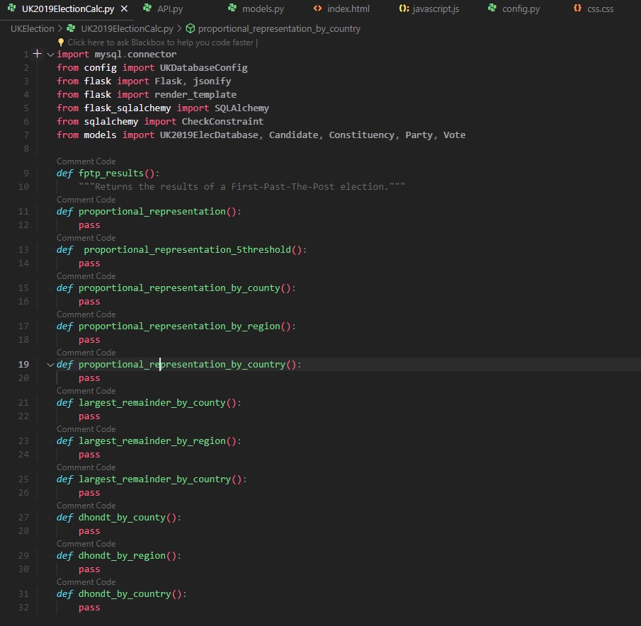
Then I made another Python script to contain the flask route functions which is critical to web frameworks, mapping URLs to actions, like serving data. (Todd Birchard, 2018)
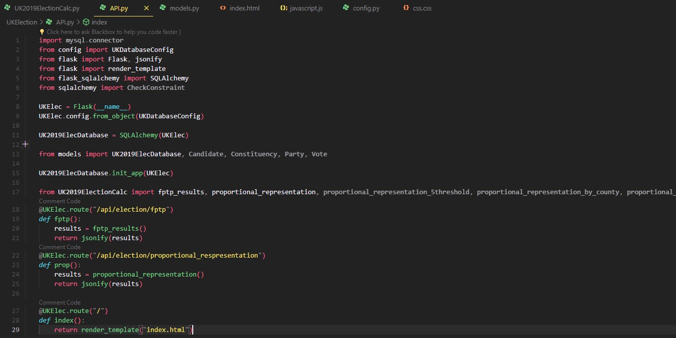
This is where the testing starts.
Connected to the database.
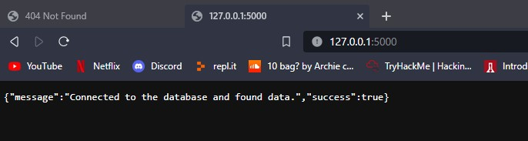
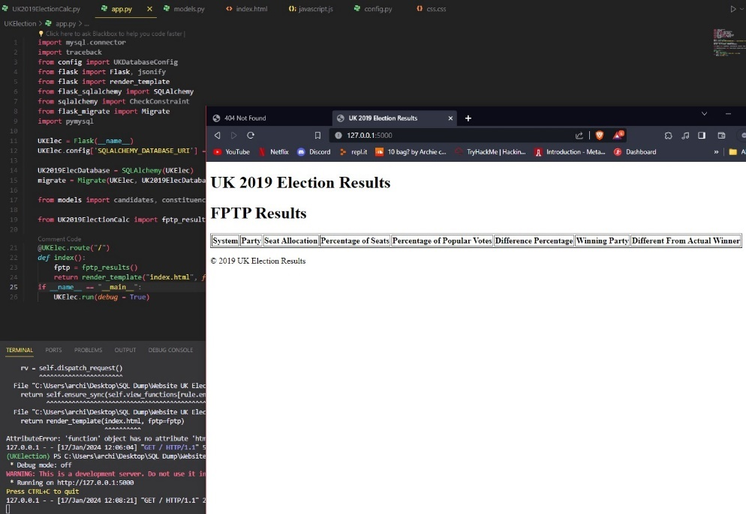
I created a fetch_data() function to ensure that the data is loaded into the calculation python script by creating a scoped session and querying each table for all results.
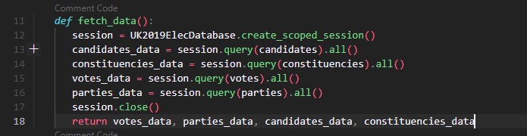
Then I finally managed to figure out how to calculate the seats by constituency, so I created a function that made use of default dictionaries (GeeksforGeeks, 2017a) to group votes by constituency, votes per party per constituency, most votes per constituency and the seats won which ran a series of for loops, nested for loops, and nested if conditions to query the data to get the relevant data back then return it. (GeeksforGeeks, 2017b)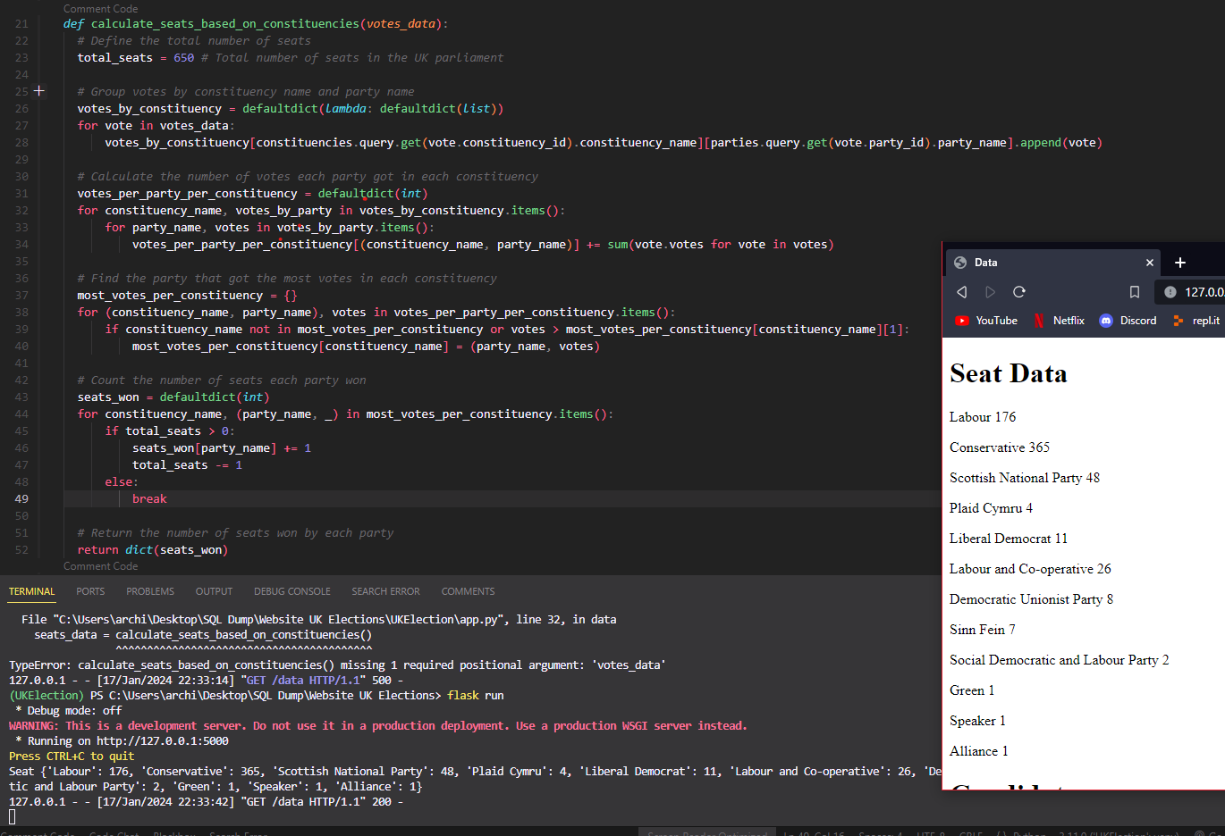
Flask Python app.py that queries the data and puts it on data.html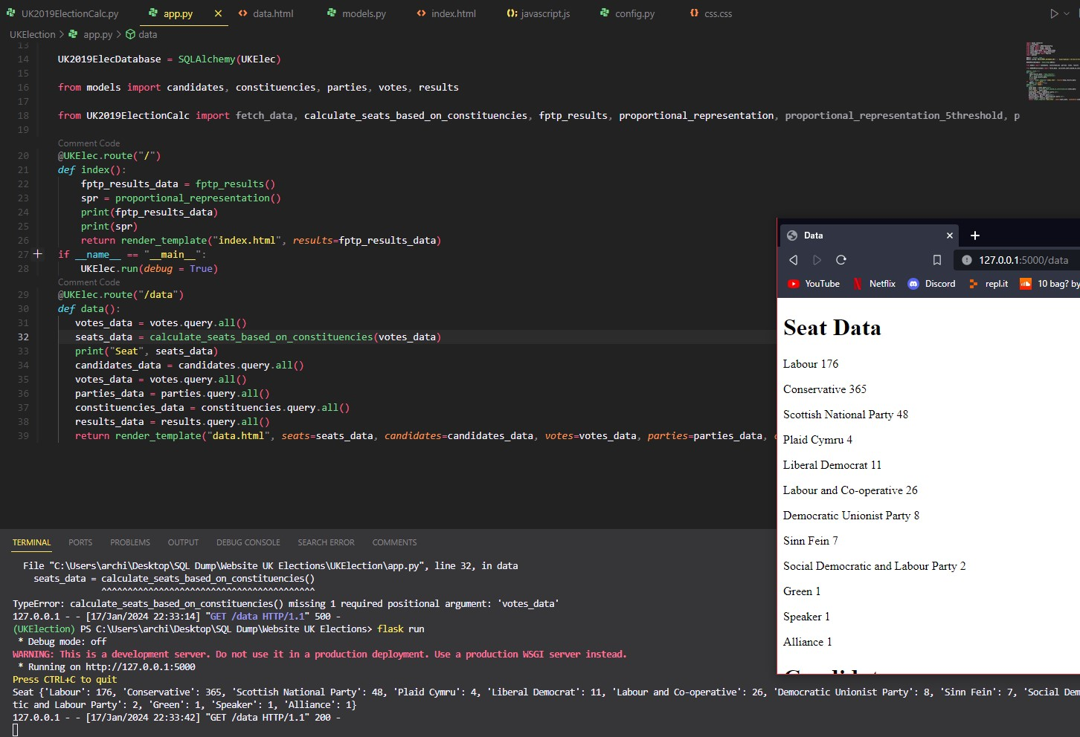
This is the final code for the FPTP results which takes the votes_data from calculated seats based on constituencies function and iterates over predetermined seats, updates it then does all the required results output calculations which get appended to the data_entry variable and then returns as result. (stackoverflow, 2014) (GeeksforGeeks, 2017a) (GeeksforGeeks, 2017b):
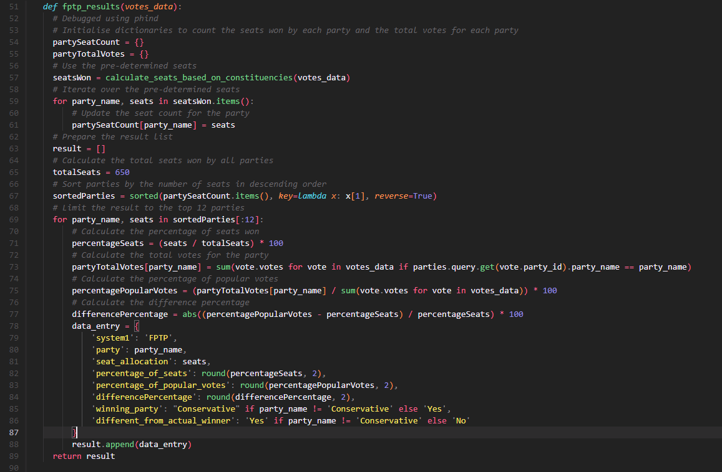
Output to the webpage:
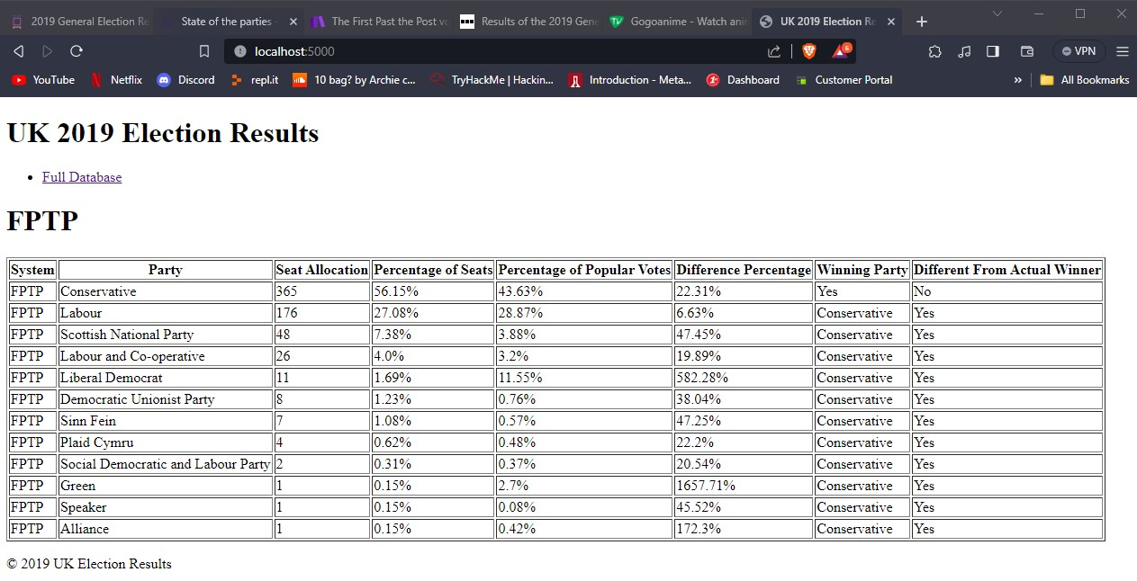
Then next was Simple Proportional Representation which after making FPTP was way easier to do as it integrates a modified version of the calculated seats based on constituency function that uses default dictionaries (RealPython, 2020) to group votes by the party name, calculate the total votes for each party, and to calculate the seat allocation for each party then sort the parties in descending order (freecodecamp, 2023). Finally, it then does the rest of the output information: “System, Party, Number of seats, Percentage of Seats, Percentage of Popular Votes, Difference Between Percentage Of Popular Votes And Percent Of seats, Party With Most Seats, Different From Actual Winner.” (stackoverflow, 2014) (GeeksforGeeks, 2017a) (GeeksforGeeks, 2017b):
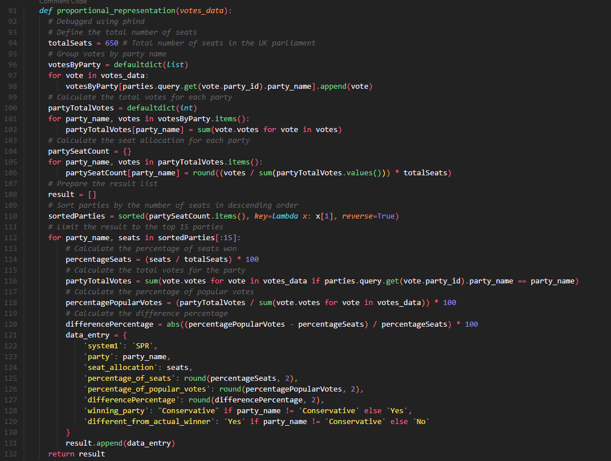
This is the output table on the website:
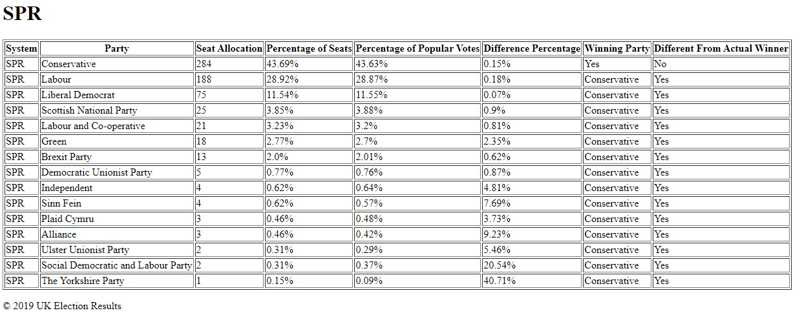
Next is the SPR with 5% Threshold which is the same as the normal SPR but the party needs to receive 5% of total votes or they are removed from the calculations, the total votes get recalculated for the remaining parties:
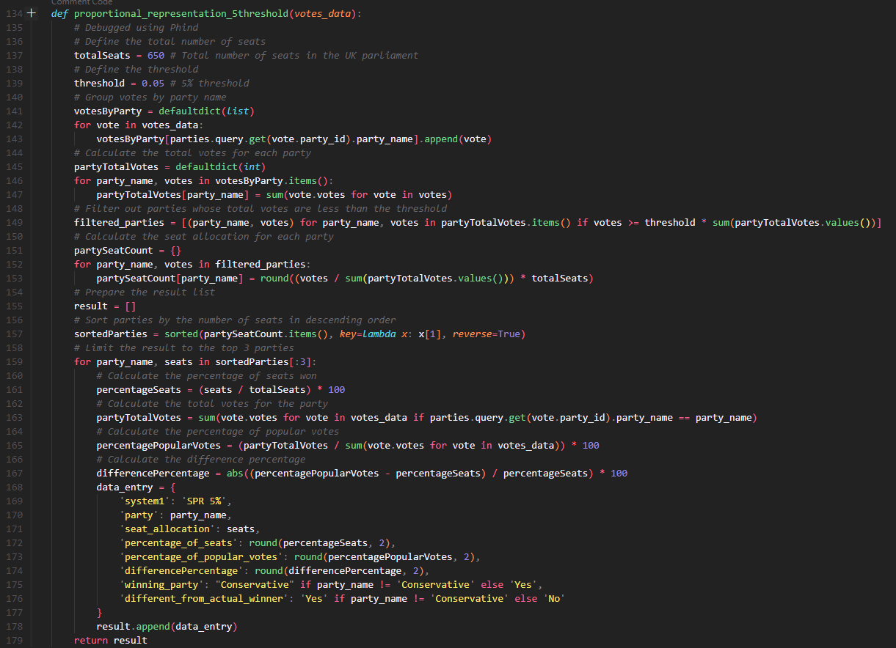
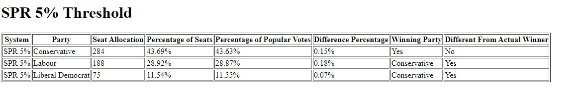
SPR by county not sure if the data output is correct or not:
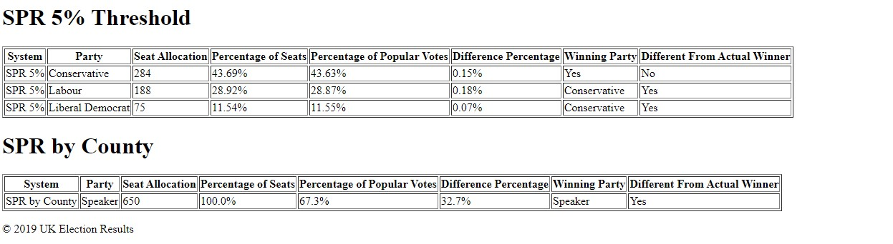
SPR by county code, the way it's calculated is the same as SPR (RealPython, 2020) by constituency but instead of constituency it is replaced with the county_name data: (freecodecamp, 2023).
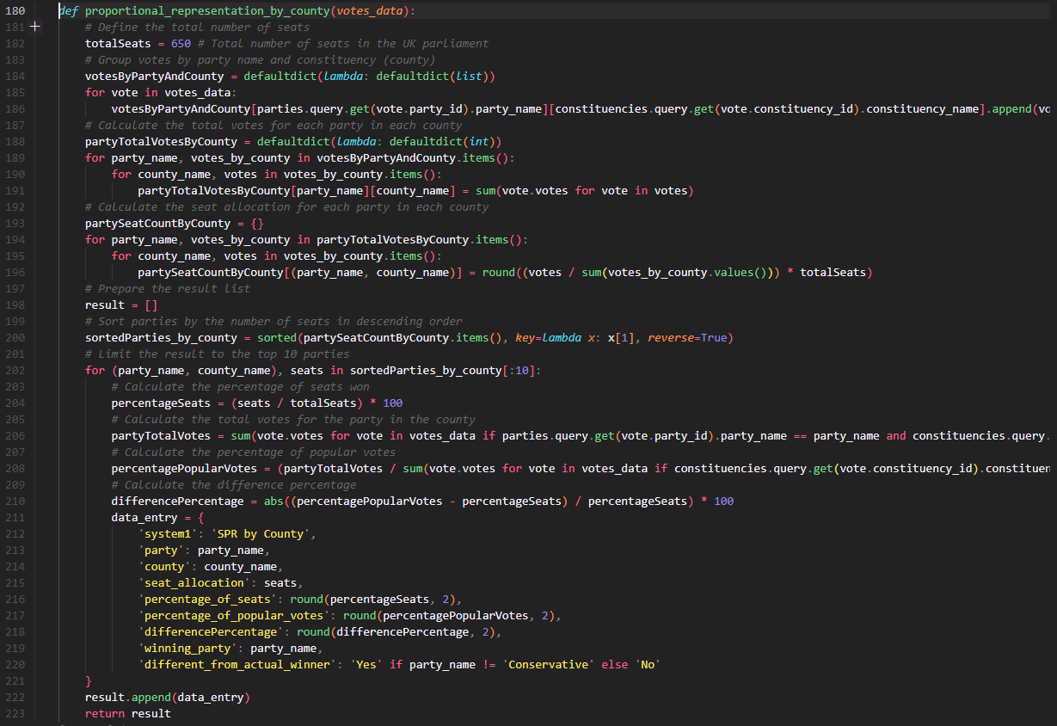
FPTP append to database Results code:
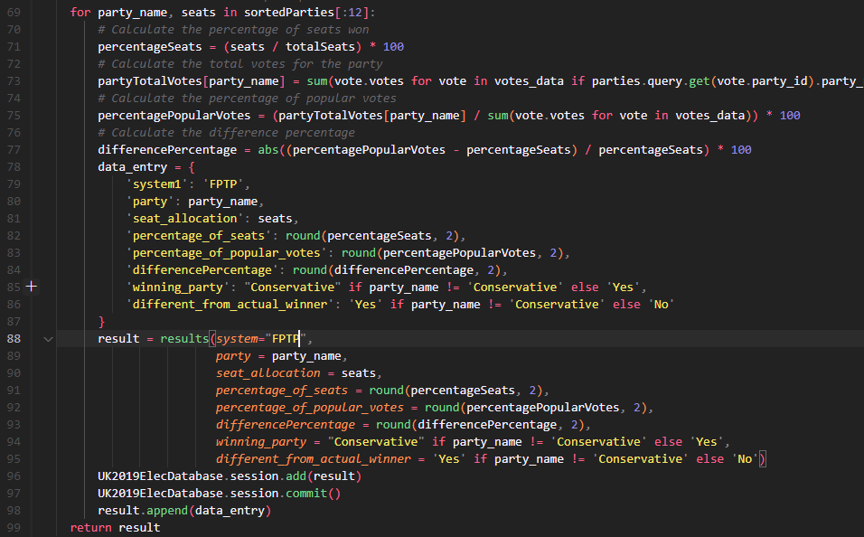
I am going to do the same thing for all current working calculations.
SPR:
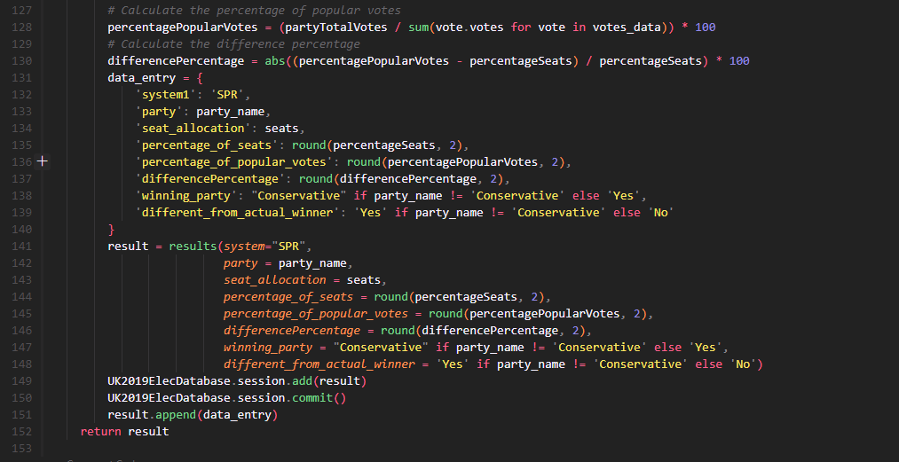
SPR 5% Threshold:
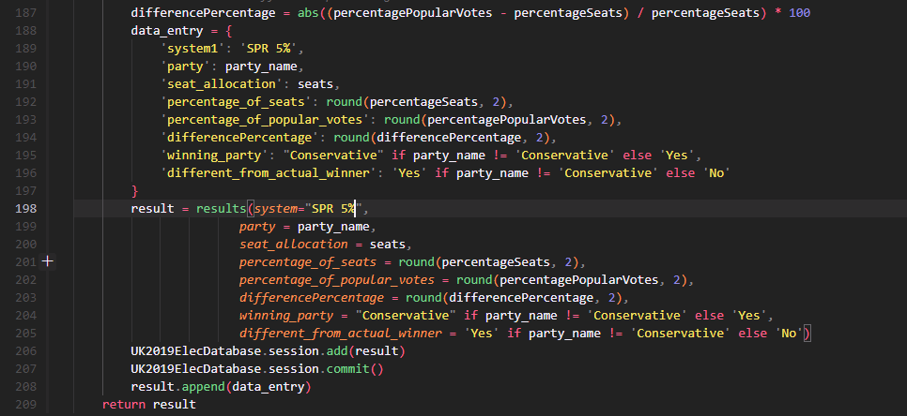
SPR by County:
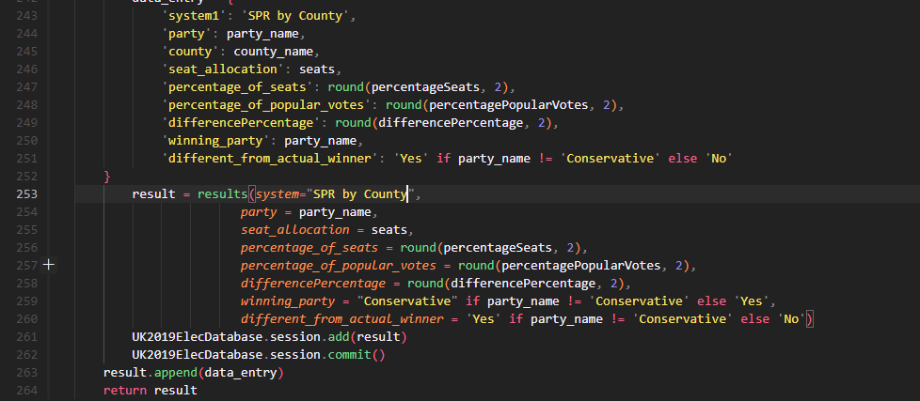
SPR by Region:
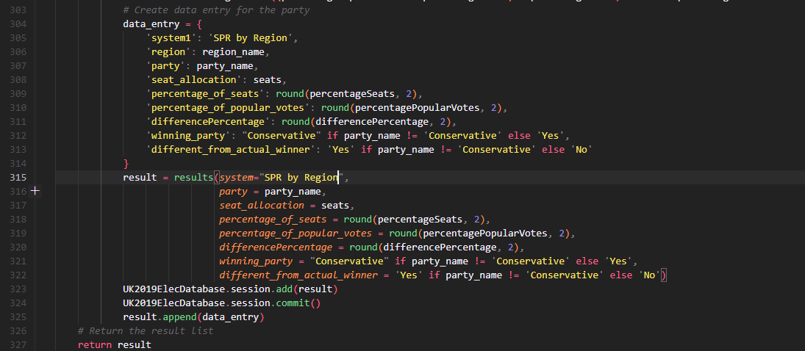
SPR by Country:
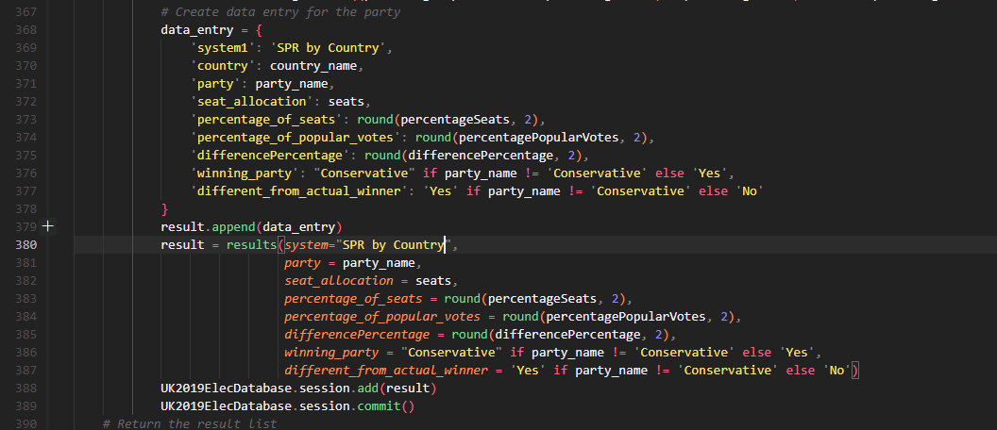
Now the typo errors and missing model variables for the database has been solved it appends data to the results table in the database.
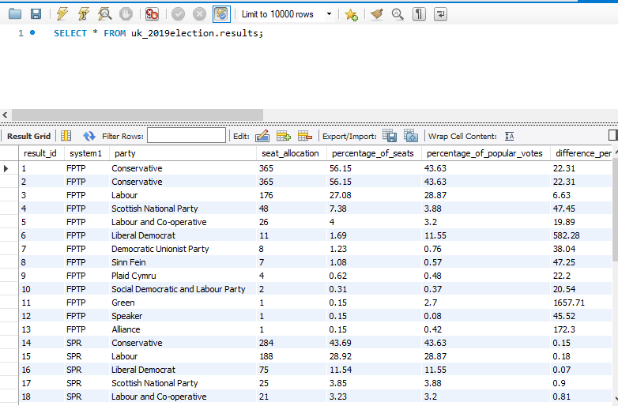
Largest Remainder by County
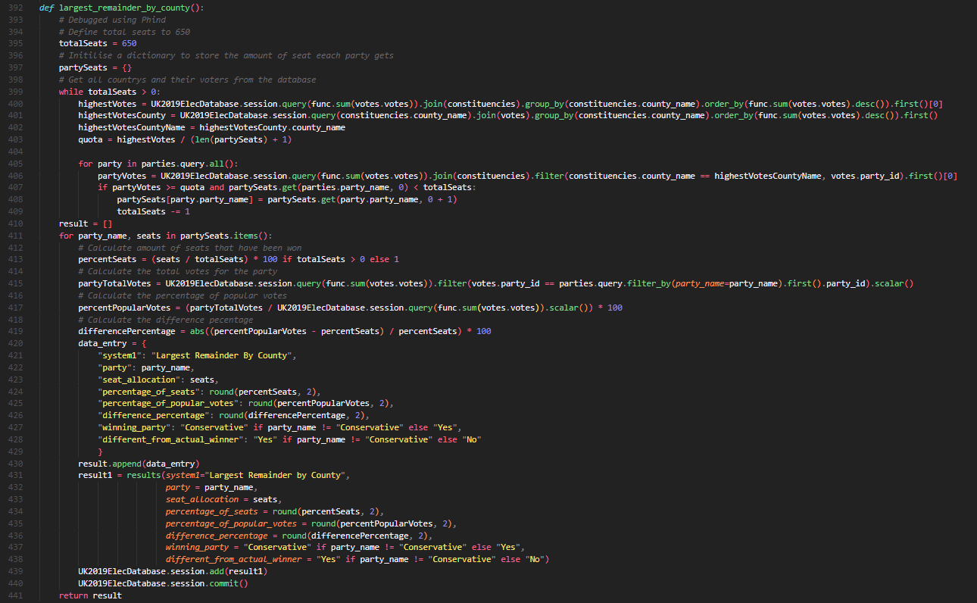
Largest Remainder by Region
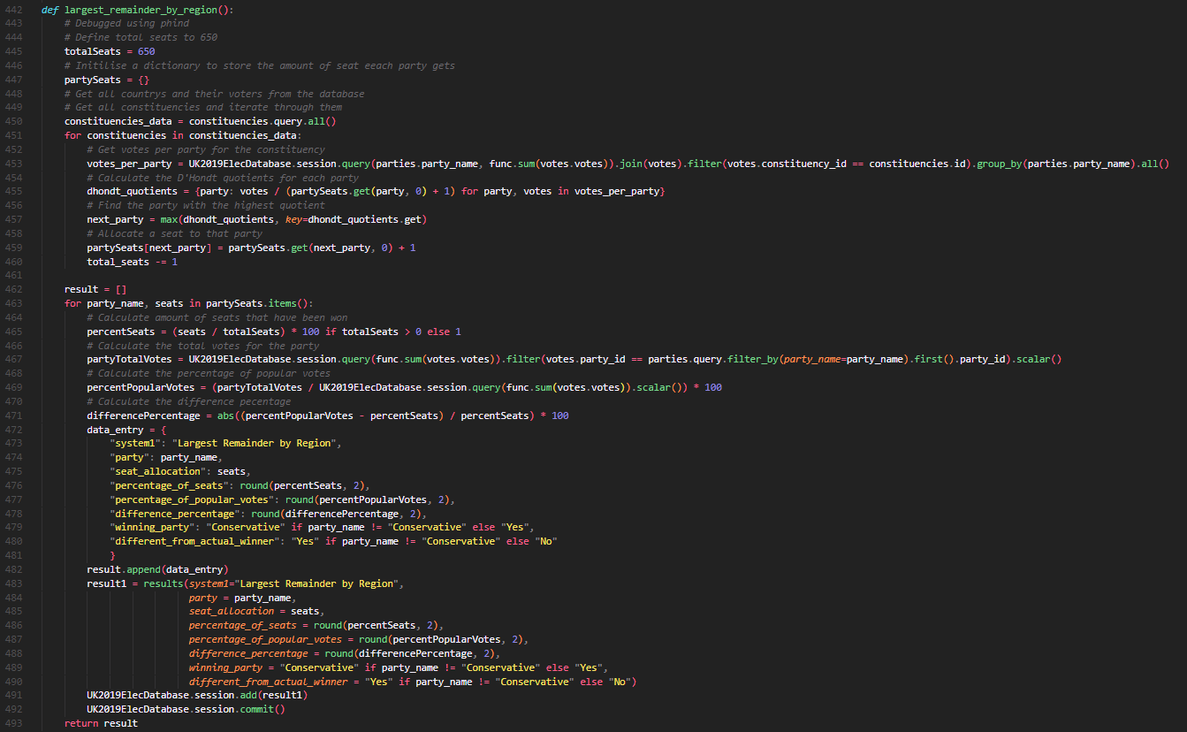
Largest Remainder by Country
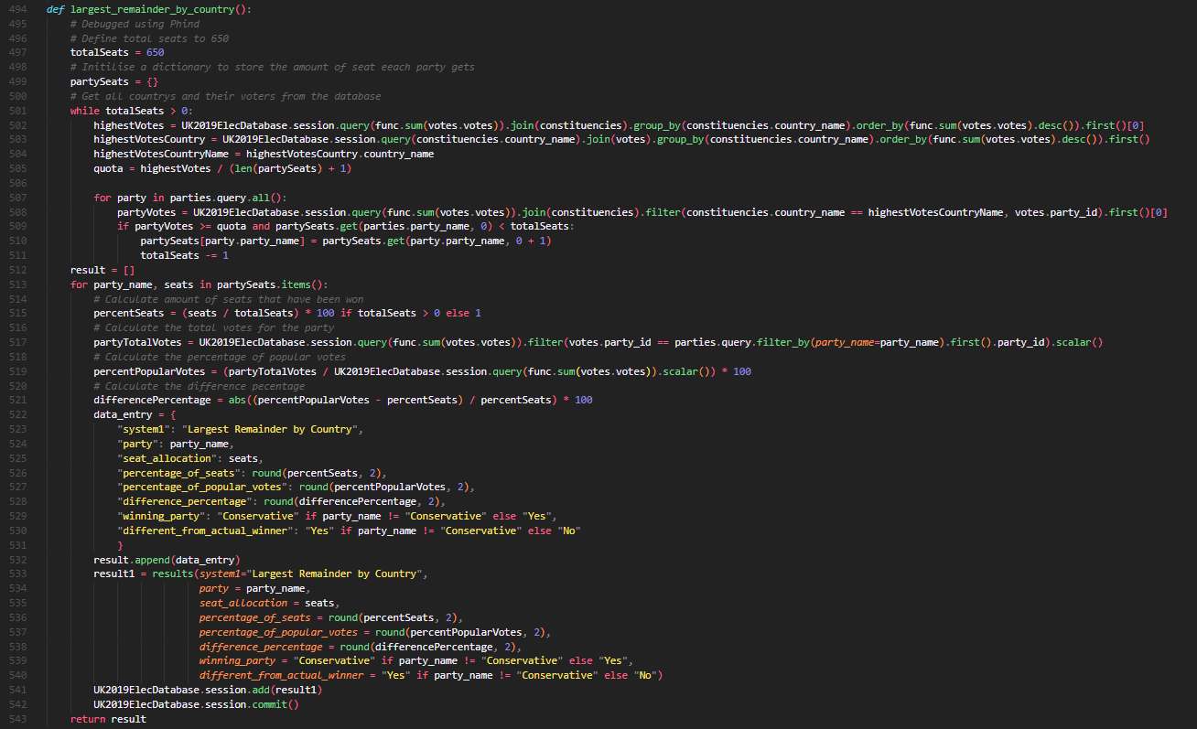
Dhondt by county
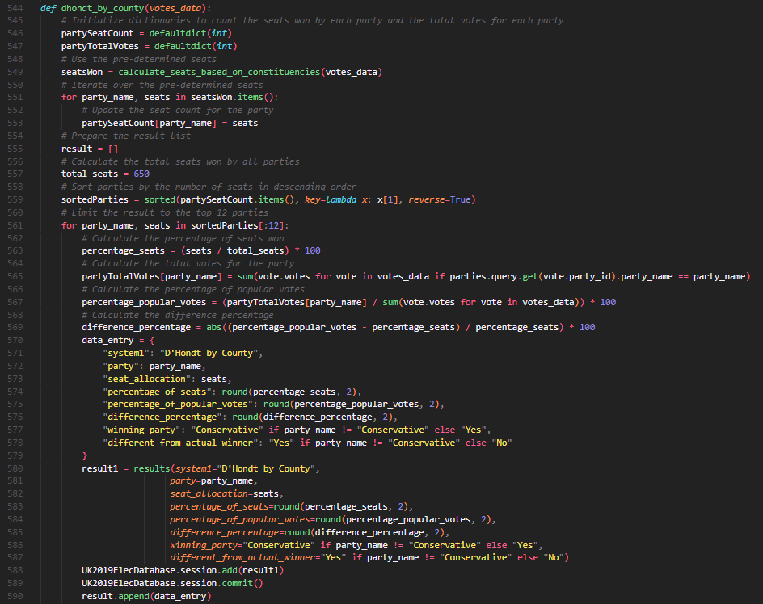
Dhondt by region
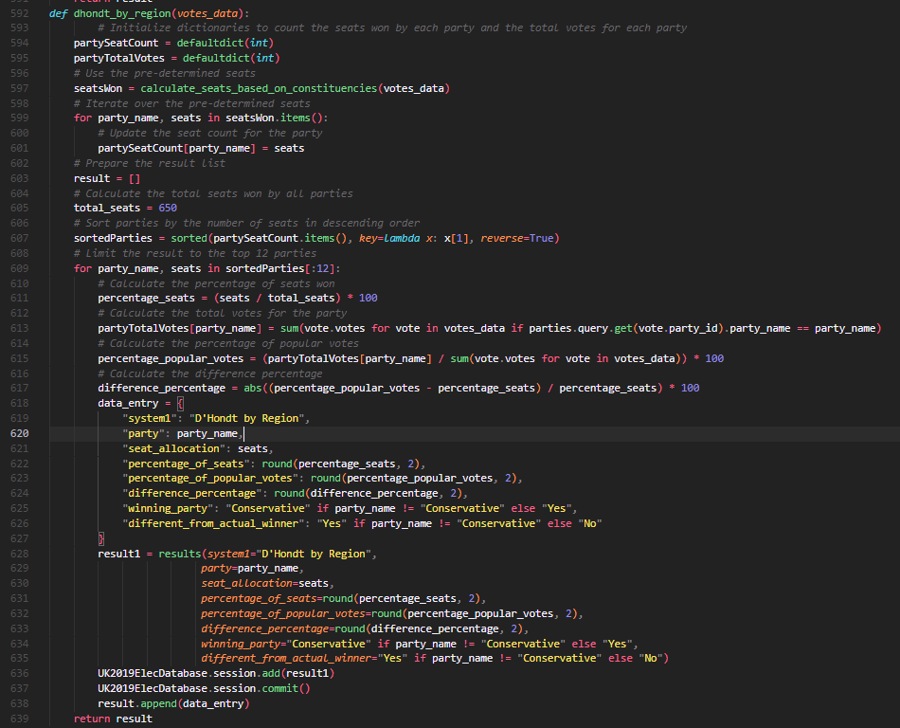
Dhondt by country
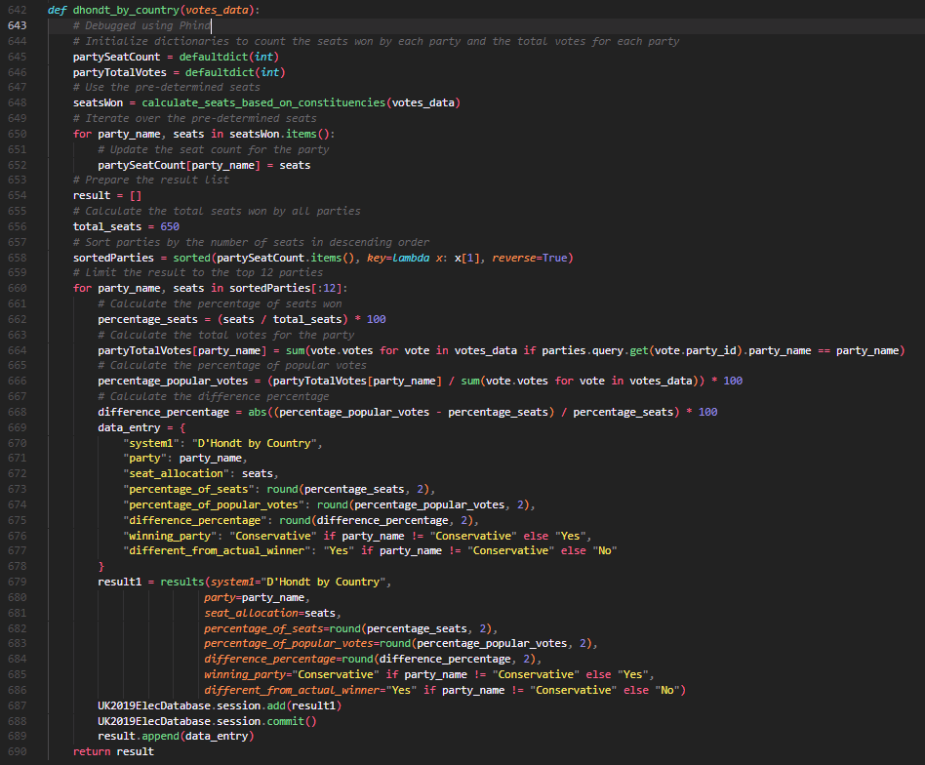

Reflections and changes throughout the process of both Snippets and annotations:
While I was creating this web application I made many changes, trials, and errors. The errors are inside the testing evidence, I first started this by just making the SQL database and had a few troubles with setting that up then I managed to get it working, couldn’t connect the Flask app to the database and kept getting errors, then I managed to spend time debugging using Phind.com inputting the error messages and finding out why my code wasn’t working and then modifying it to get it to work, throughout the coding process I tried to make the results all output onto one page which caused it to not load at all and for some of the calculations made the website run very slow and take forever to load so I separated them to be output onto a different web page, I also realized that I have not appended data to the Results table which will contain the result of each electoral calculation and store it in an SQL database. So going to change that and add snippets of it.

Testing Evidence:
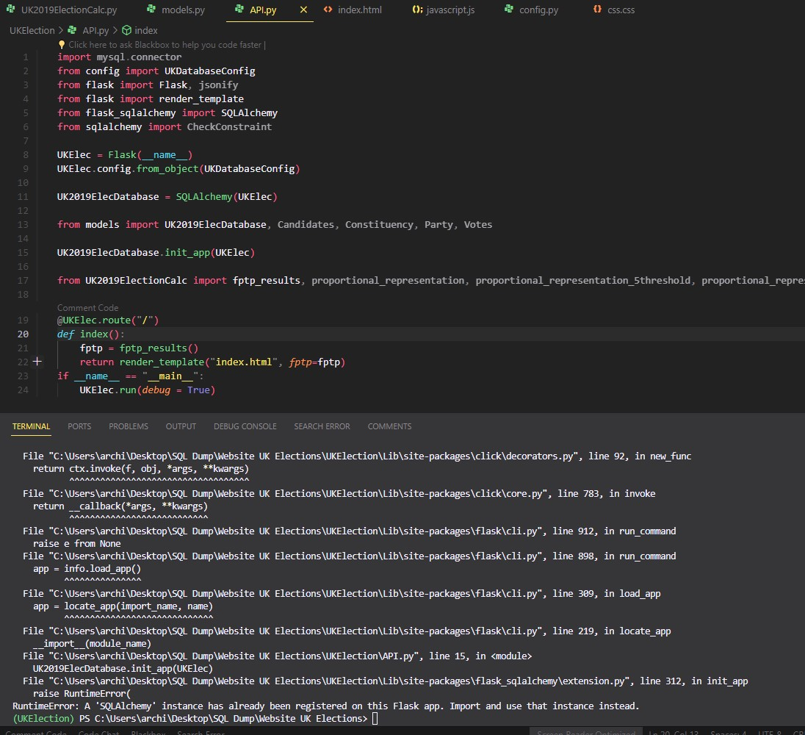
This was caused by a duplication of initializing the flask app twice.
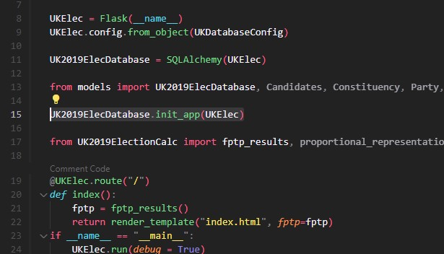
This is where I try running the Flask app to make sure it is connecting to the database and models.
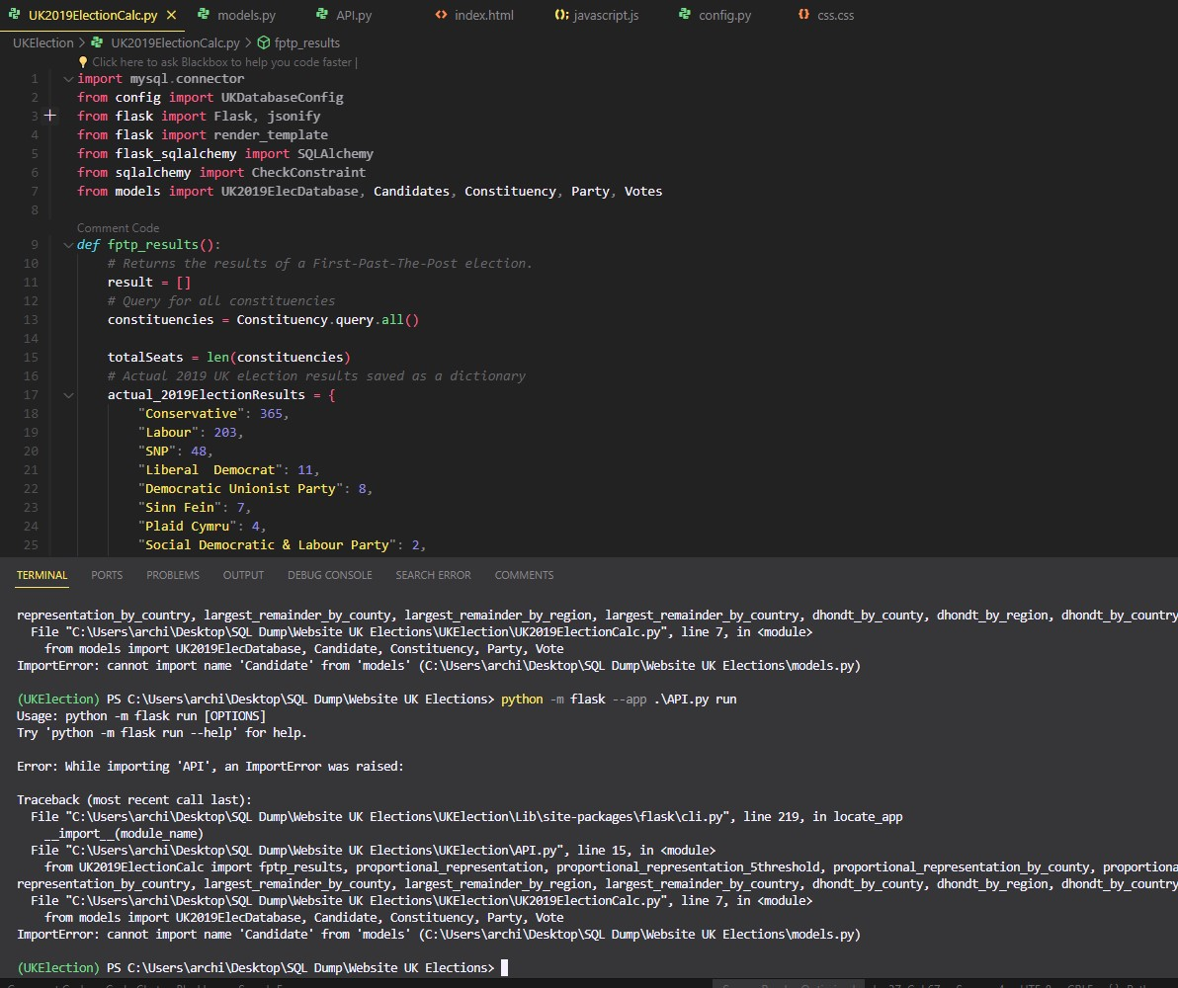
App then runs but won’t show webpage without throwing errors:
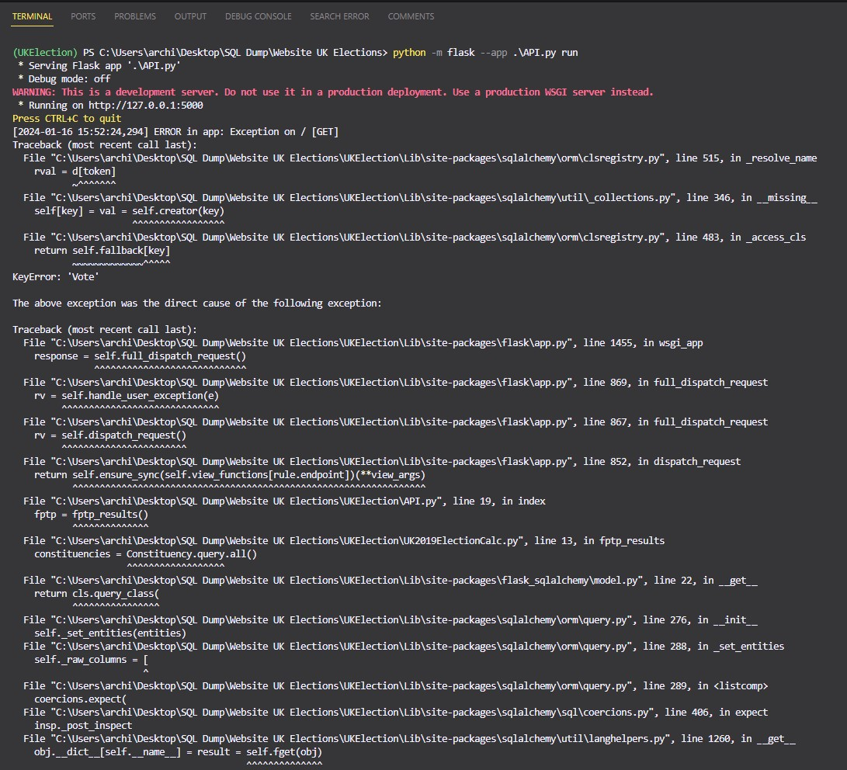
Caused by typos in my models:
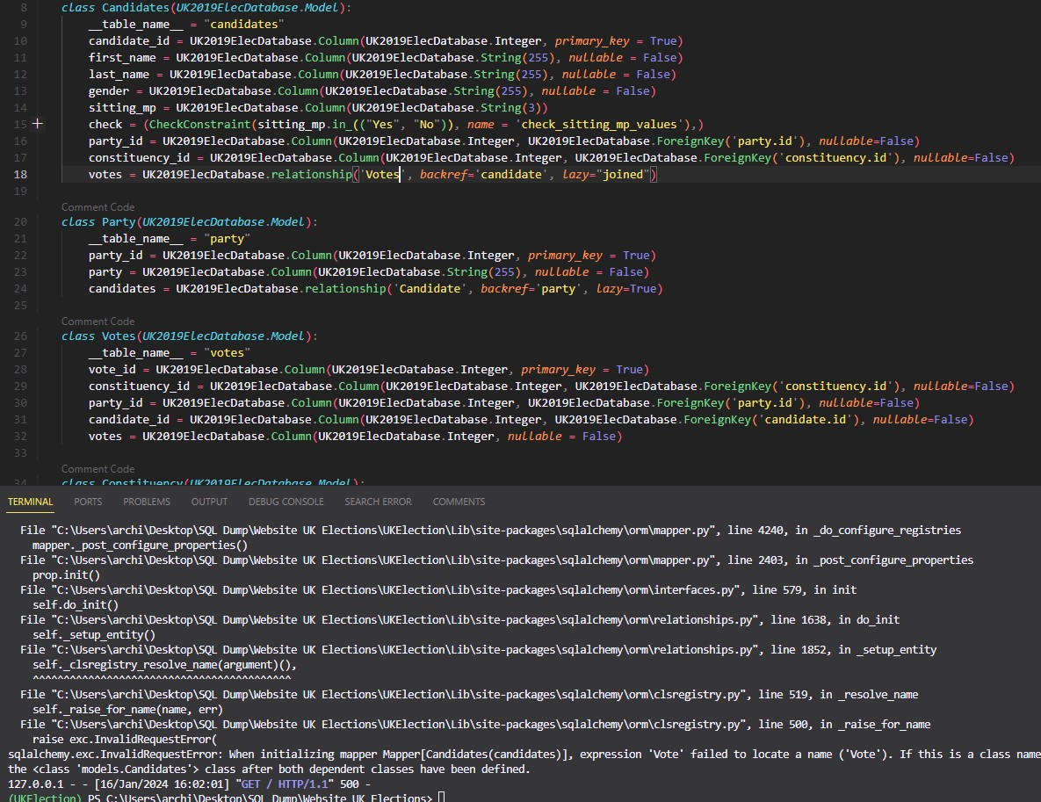
So I fixed the typos throughout the models file (DigitalOcean, 2022):
Had more errors with the first attempts at FPTP calculations:
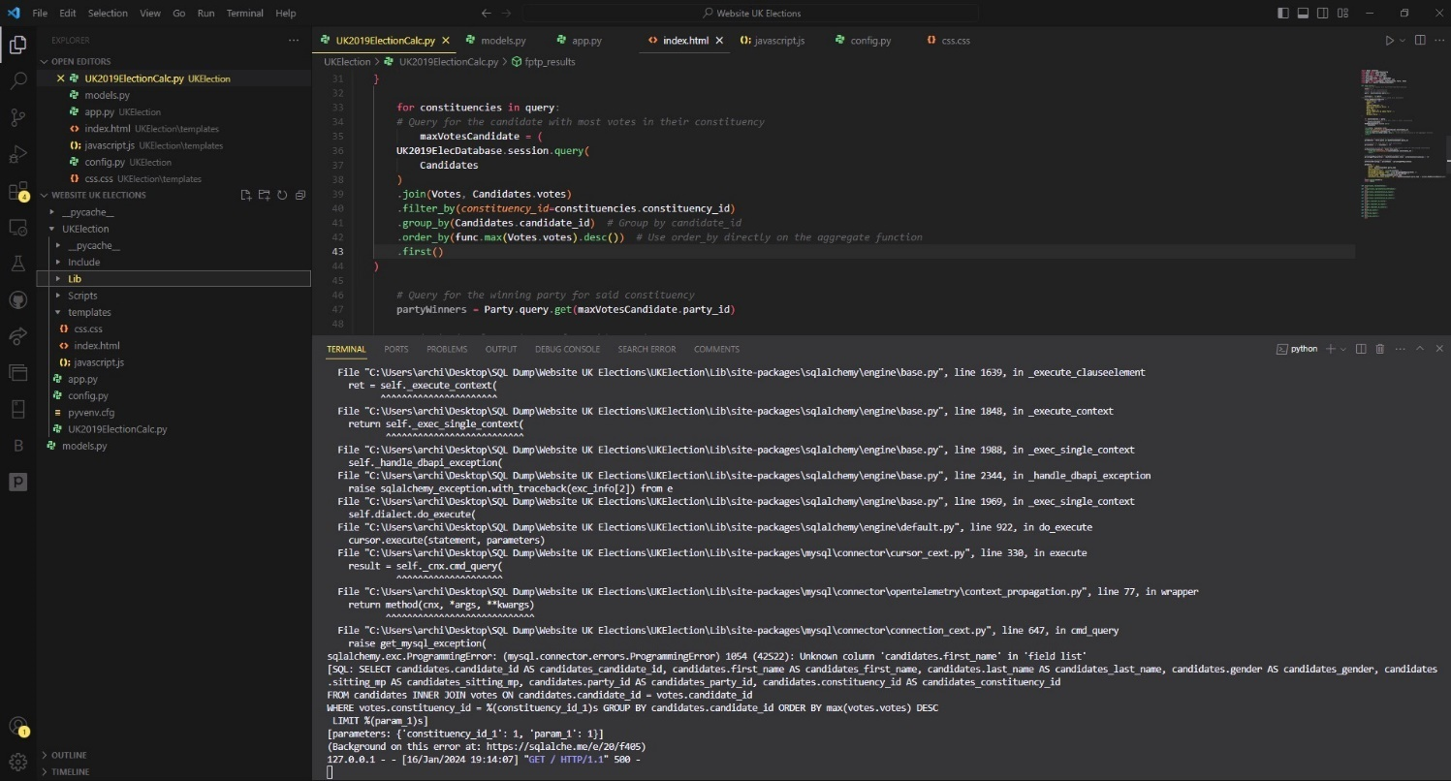
Concluded the database was either not connecting or the models/calculation code was calling the wrong object name. Then I created some code to throw messages in the console for testing database connection & removed the need for a config file and used the code below to just connect it to the UKElec flask application.
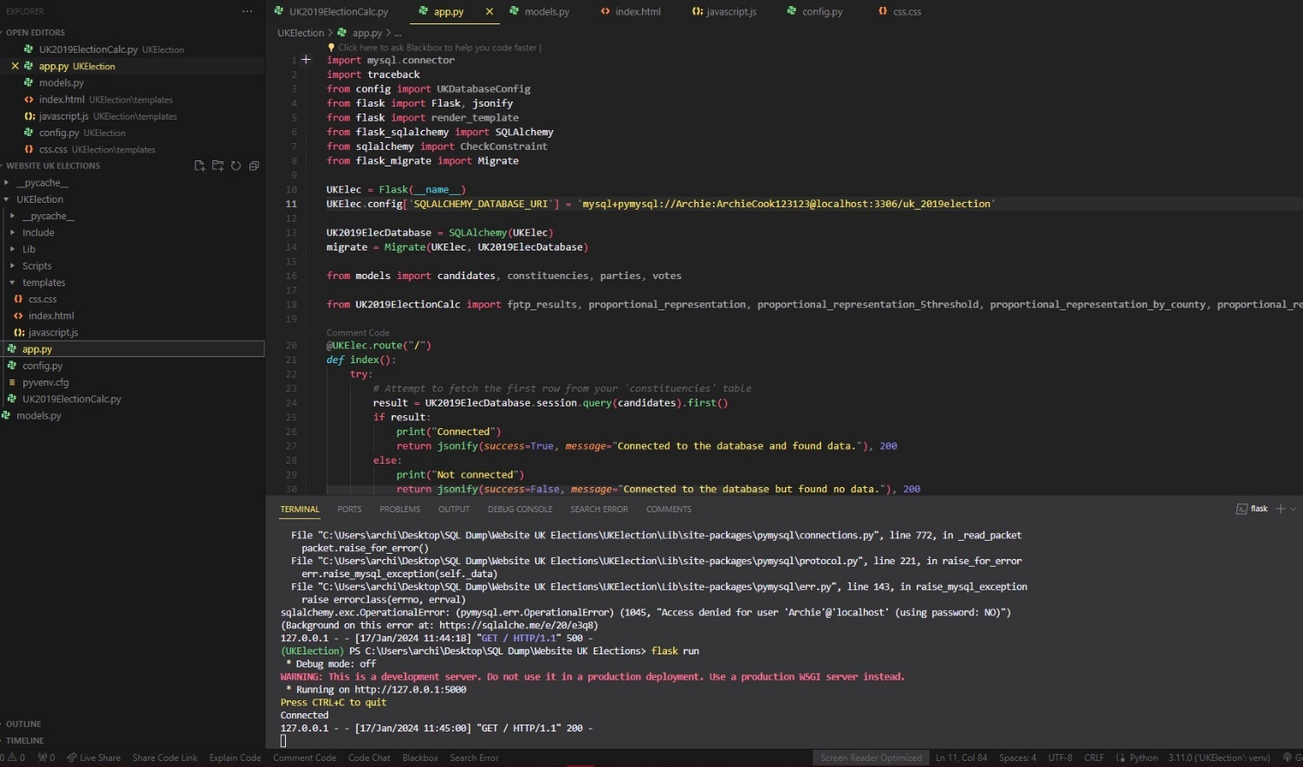
Shows database is connected.
Then I added some testing code that I forgot to screenshot but gave me these outputs to test if max votes candidates had a value, print the number of constituency_ids, and results list.
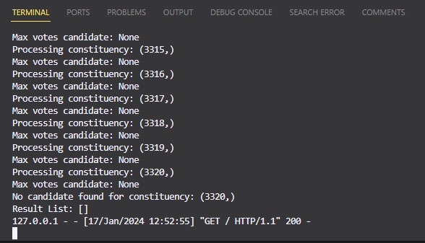
Then I managed to get the data to be retrieved by the database and processed using FPTP calculations and print them to console to find out why they weren’t showing on the website. (SQLAlchemy, 2024b)
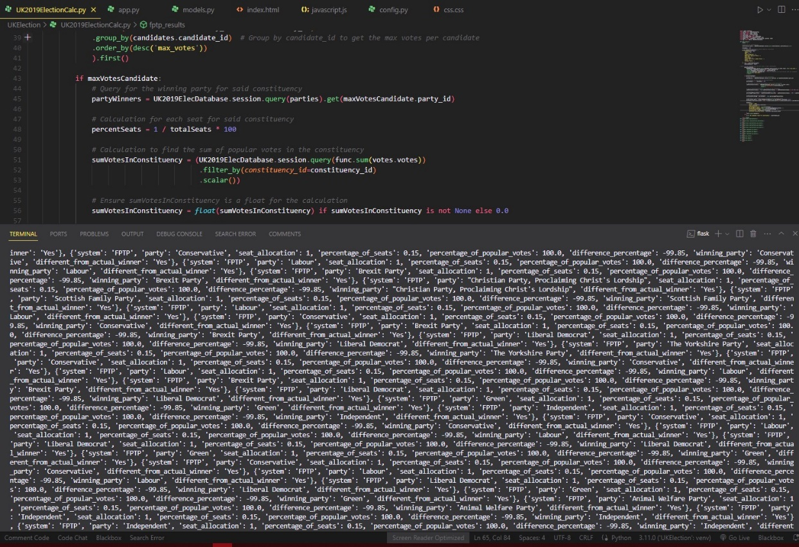
The data was not showing due to typos in variable names in Python and HTML, I corrected them and then it shows this data which is wrong:
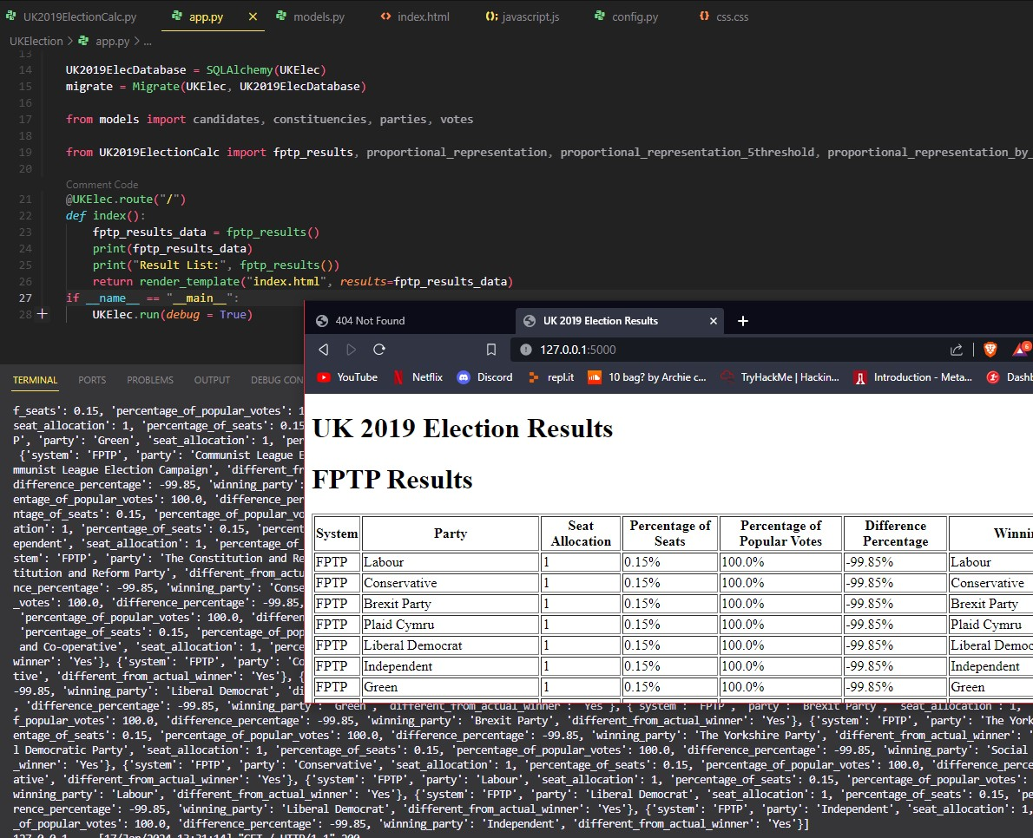
Even though that FPTP was wrong I moved on to the SPR and it wasn’t accessing votes and throwing errors, so I made some code to print to the console to test the outputs.
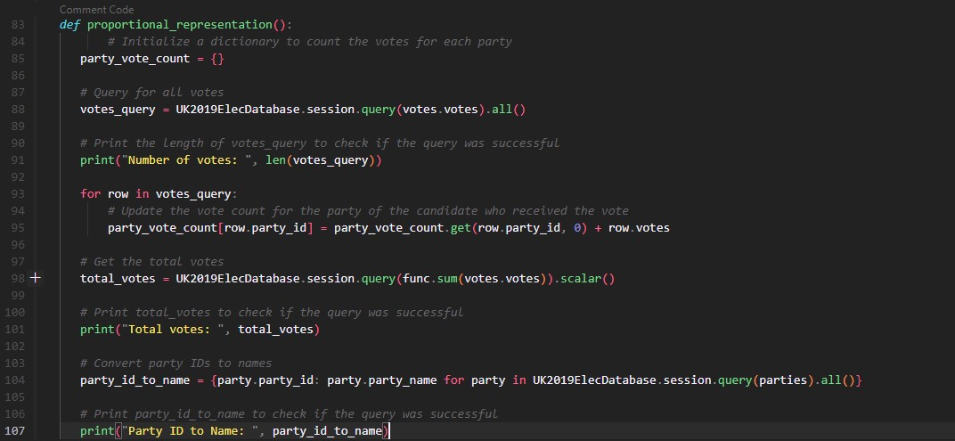
Since I was unsure of what was causing the errors I made a test database HTML site that shows the full database:
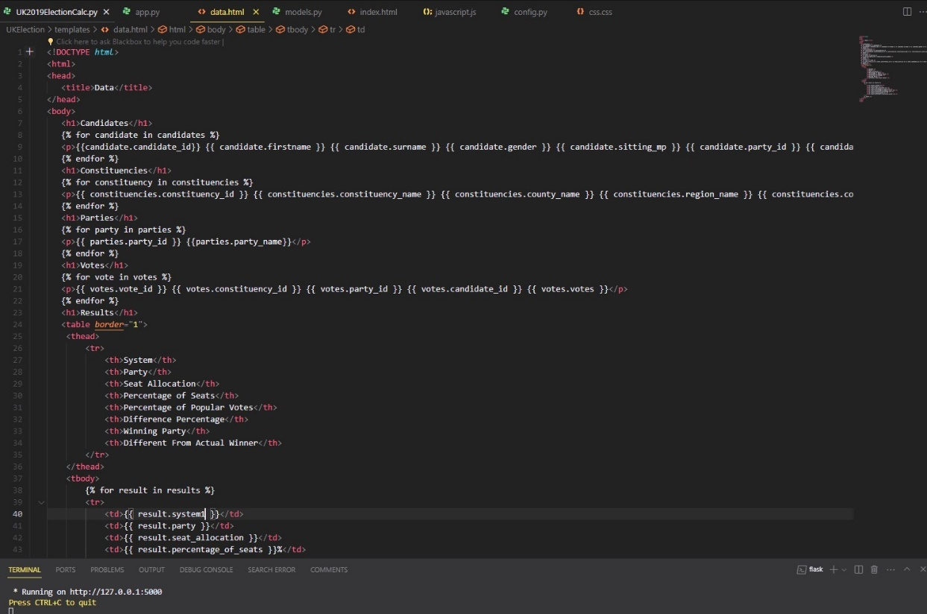
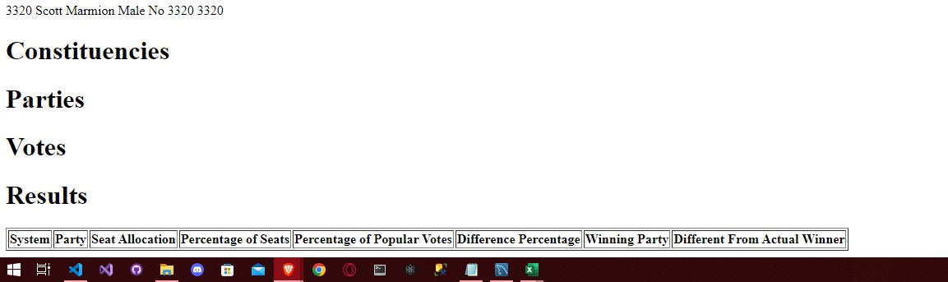
This shows that only candidates were being shown at first I thought it wasn’t being loaded in but turns out it was just HTML typo errors. I fixed them then all the data printed to the site.
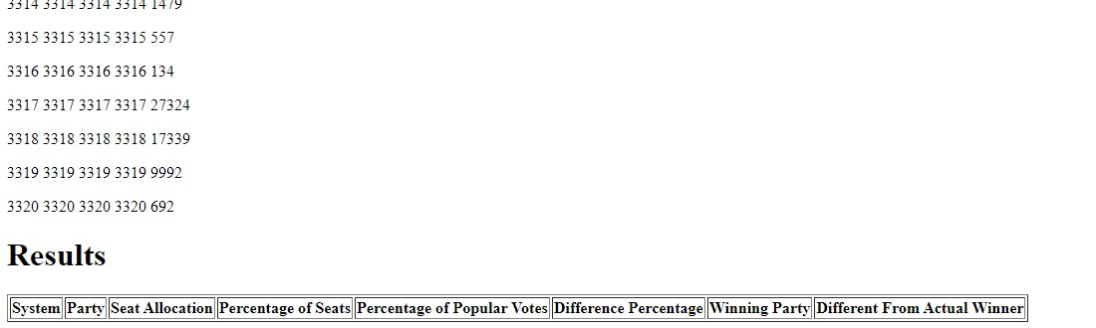
Fixed the region and country SPR error however now the site just pends and wont connect and display to site not even to terminal
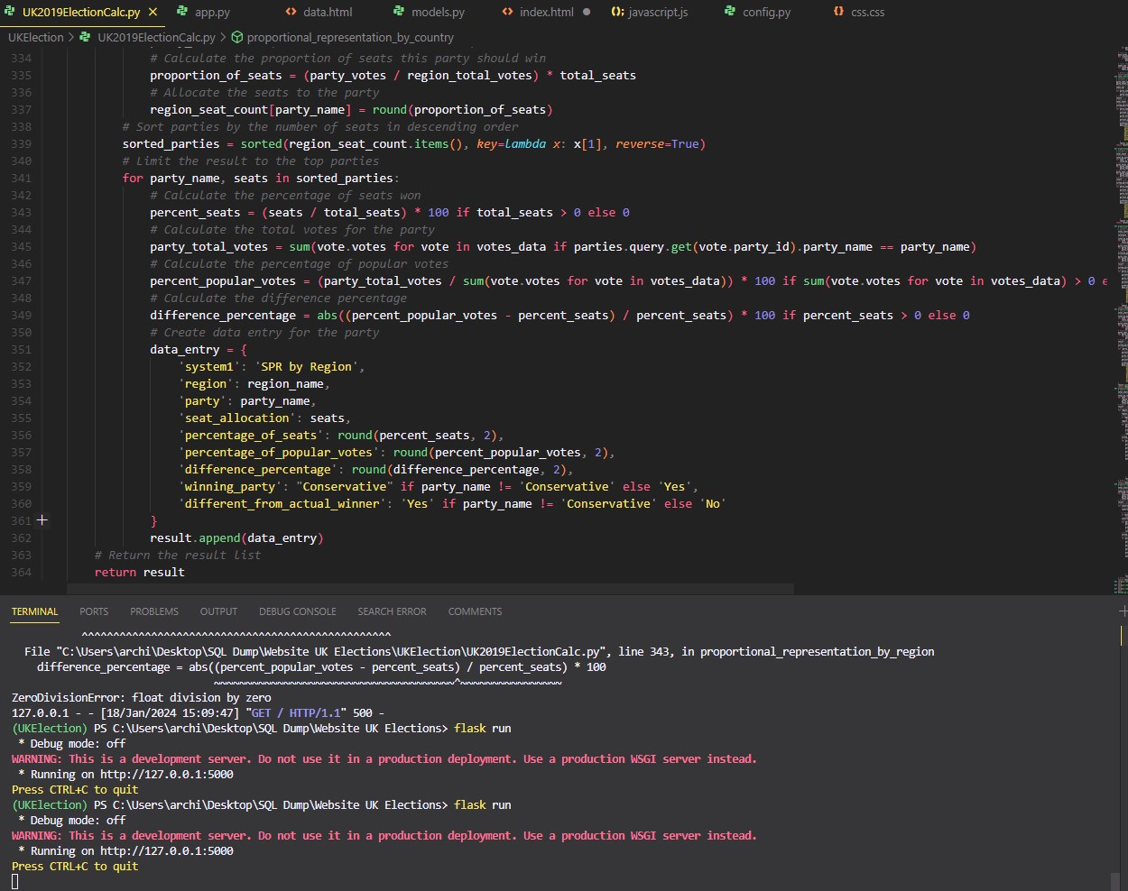

Not loading: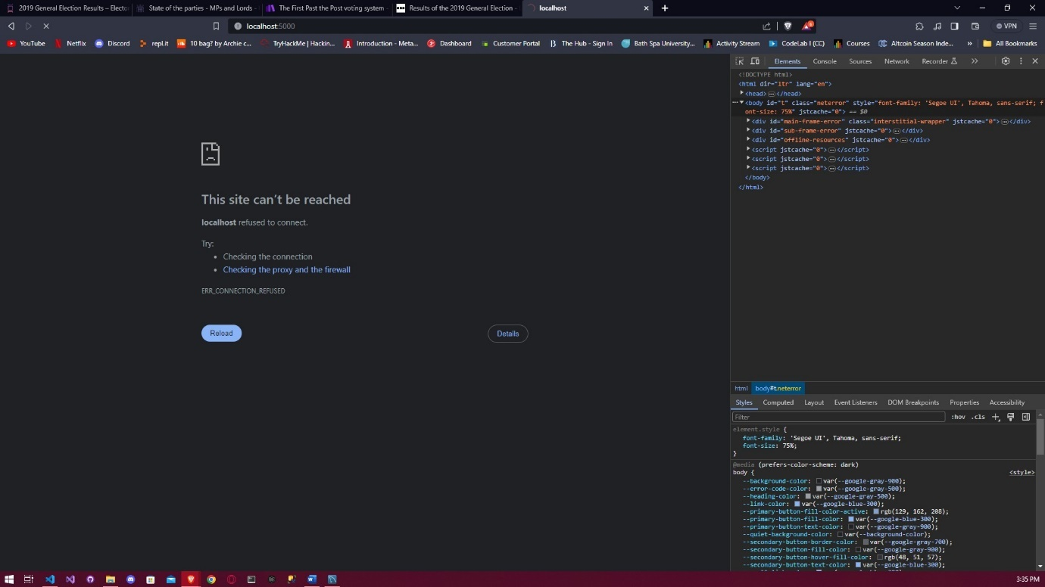
Tried using joinedload from SQLAlchemy.orm to use Eager loading to prevent the N+1 querying problem and to optimize it: (GeeksforGeeks, 2024)
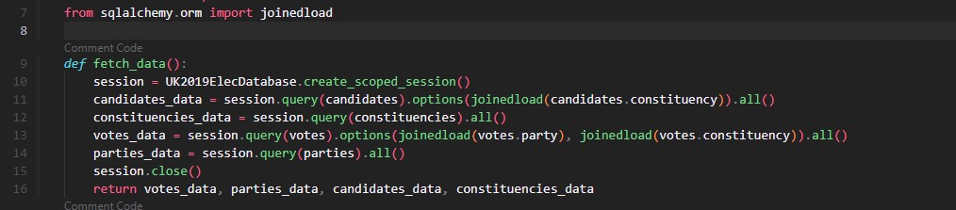
Since the website was not loading when I was trying to see data on the website for SPR by Region and Country I created separate HTML documents to showcase the data for SPR Region and Country, then I also did the same for Largest Remainder and Dhondt.
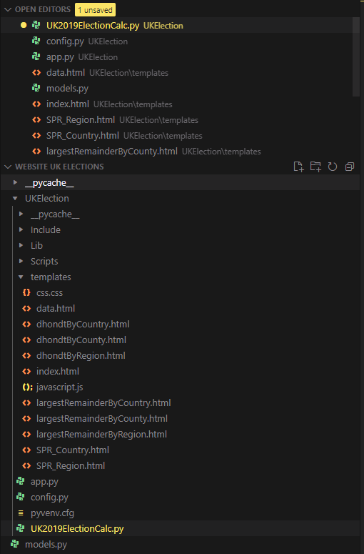
Region Flask route and HTML:
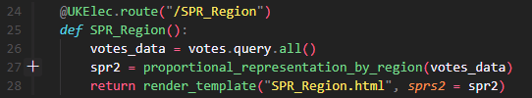
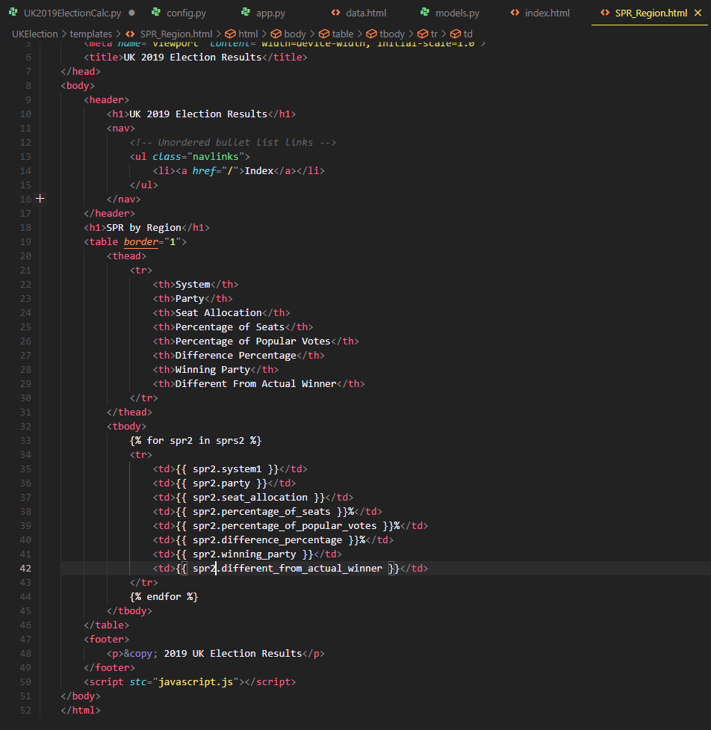
Country flask route and HTML:

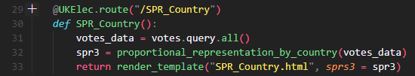

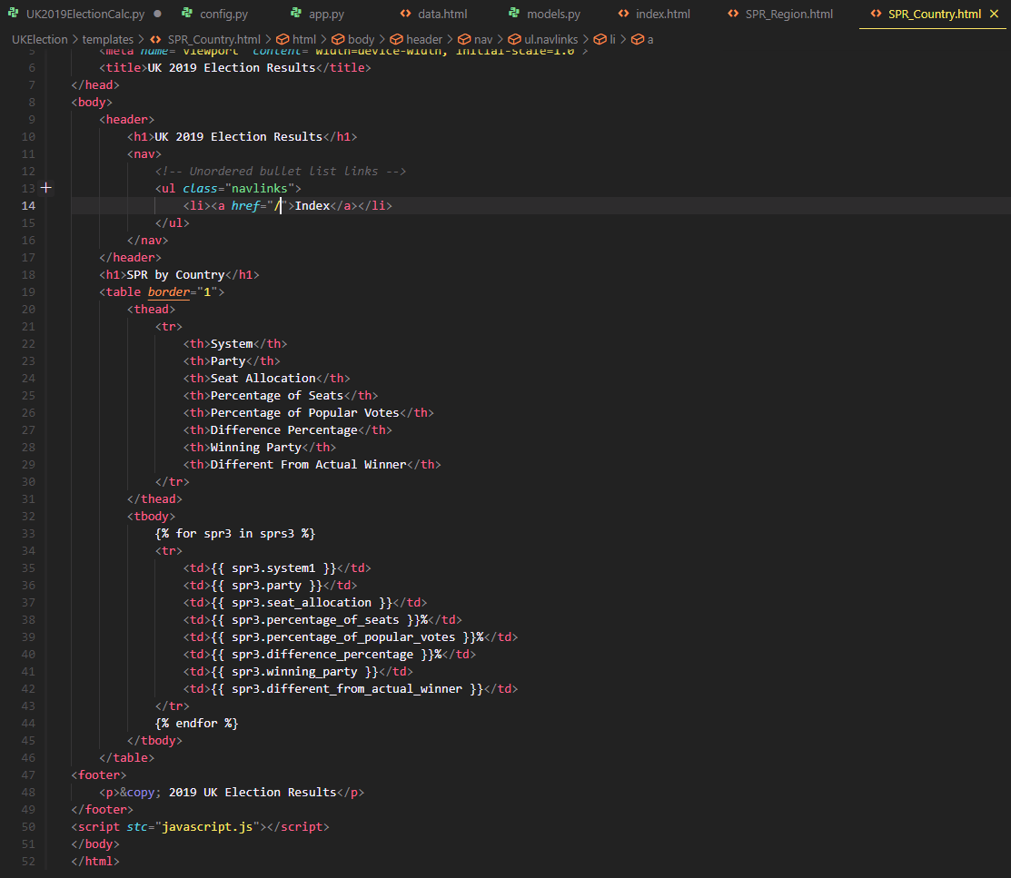

All Flask routes:
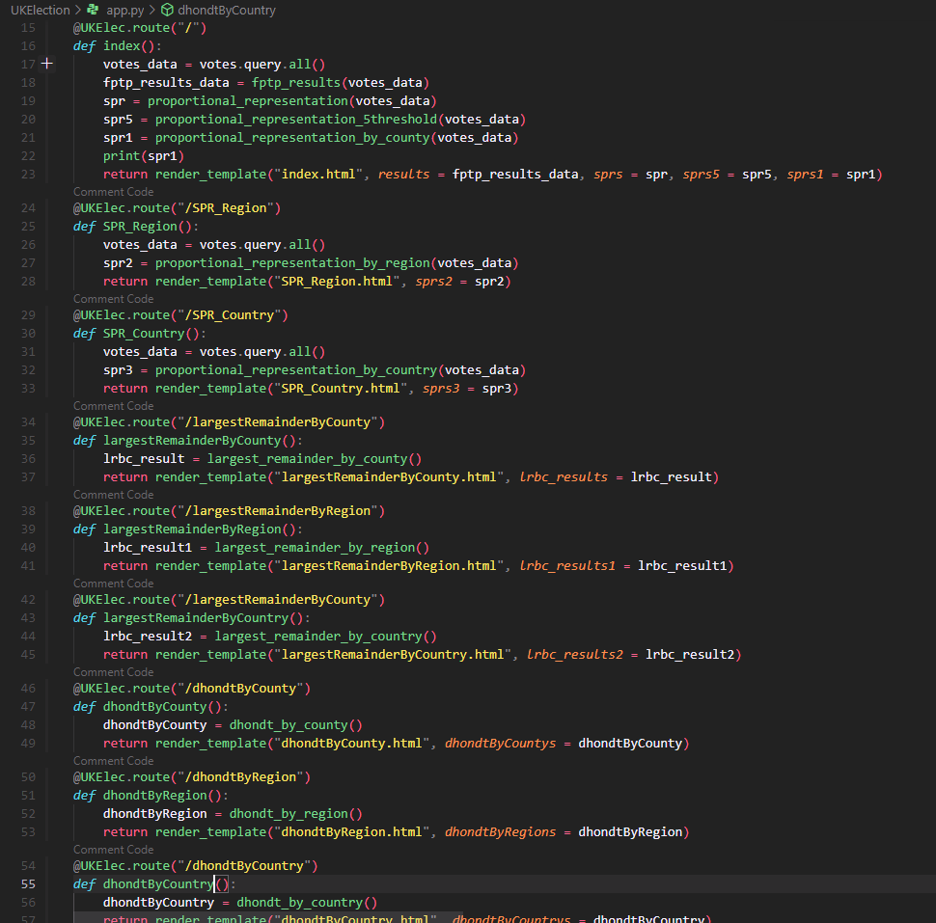
Typo-ed the system variable when it should be system1 causing internal server error.
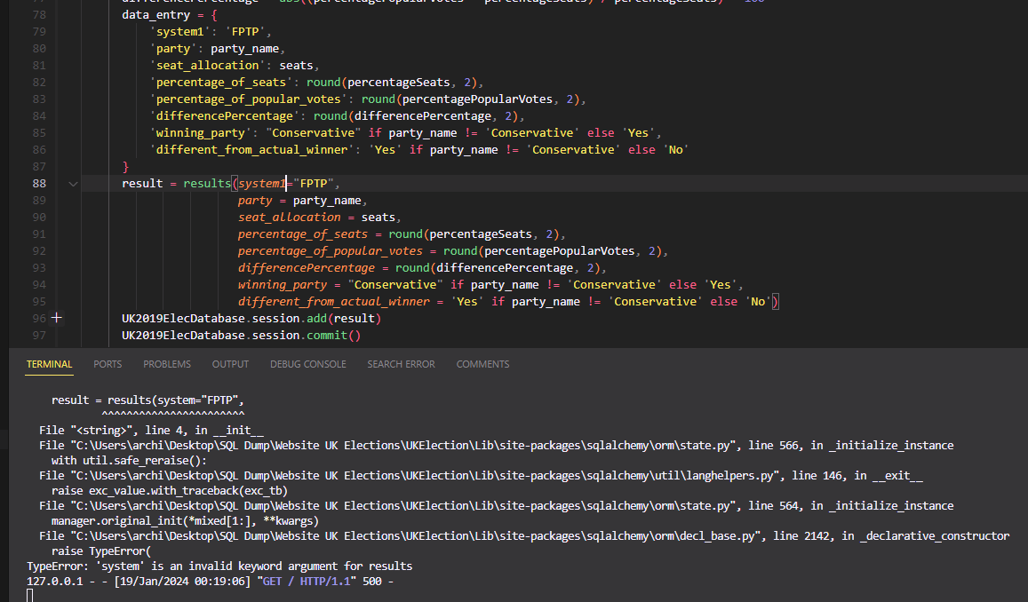
Typo-ed the difference_percentage as differenceParty:
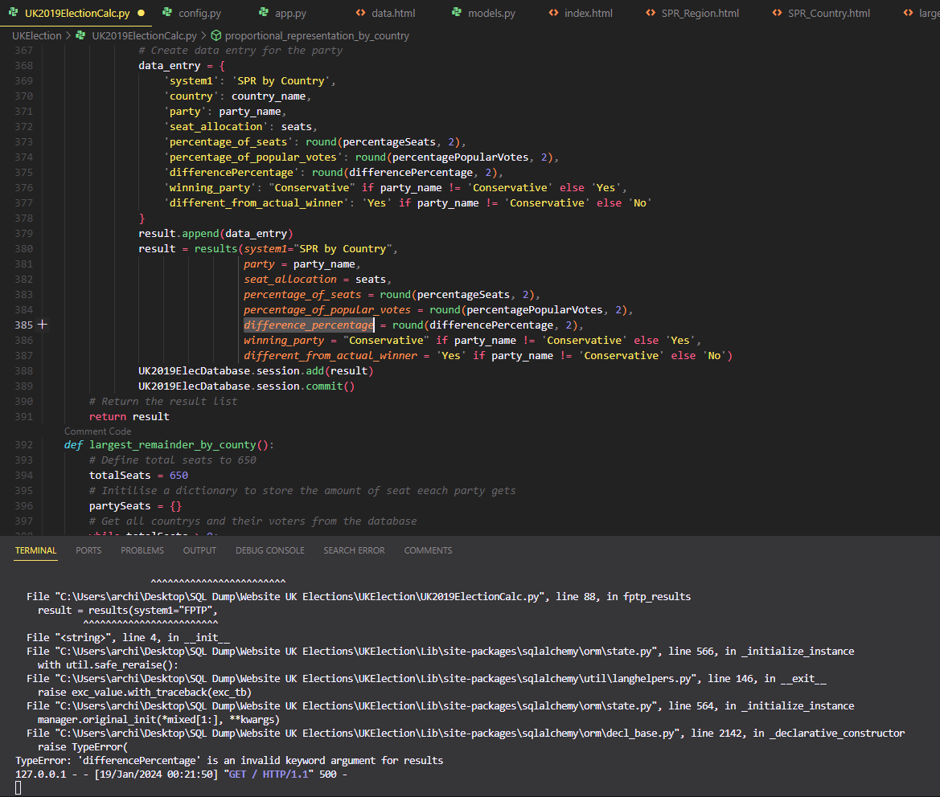
Typo-ed again from what the models are:
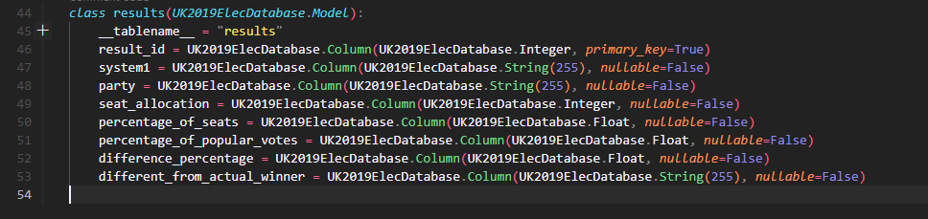
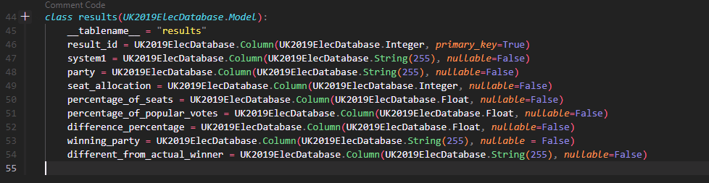
Result was being used for two variables, so I fixed that by keeping one as the variable result and making the database append result1.
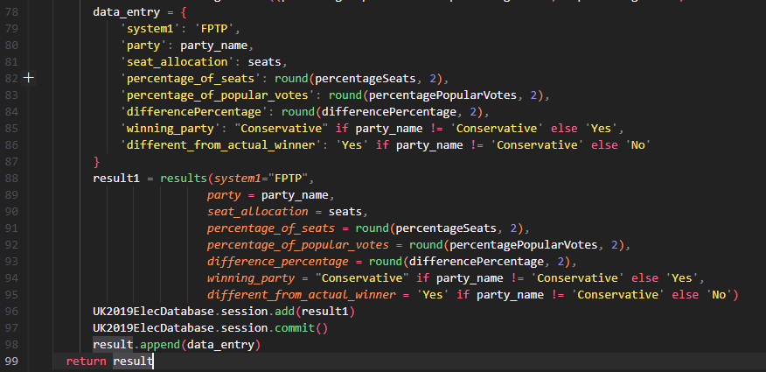
Now can see the data has been appended to the results table:
The Largest Remainder was throwing this module object is not callable: 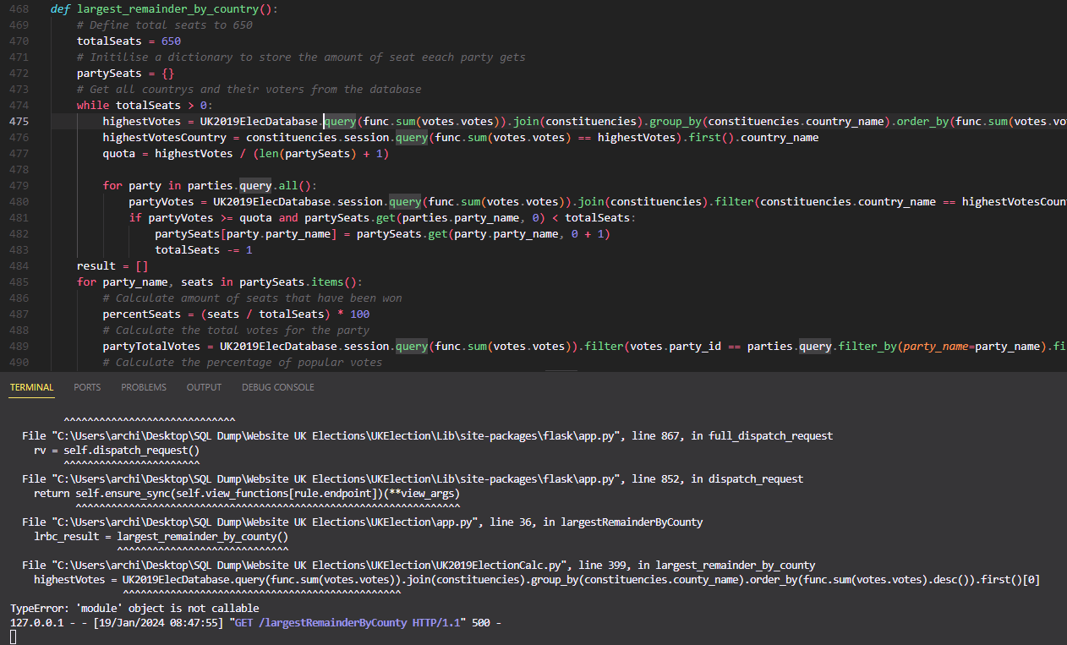
This was due to calling the database in a way that its treated as a function or method to fix this just need to add .session to it. (freecodecamp.org, 2022)
Adjusted the percentSeats variable to add an if condition as it was returning 0 since that throws errors, and I want it just to load this is a quick fix solution.
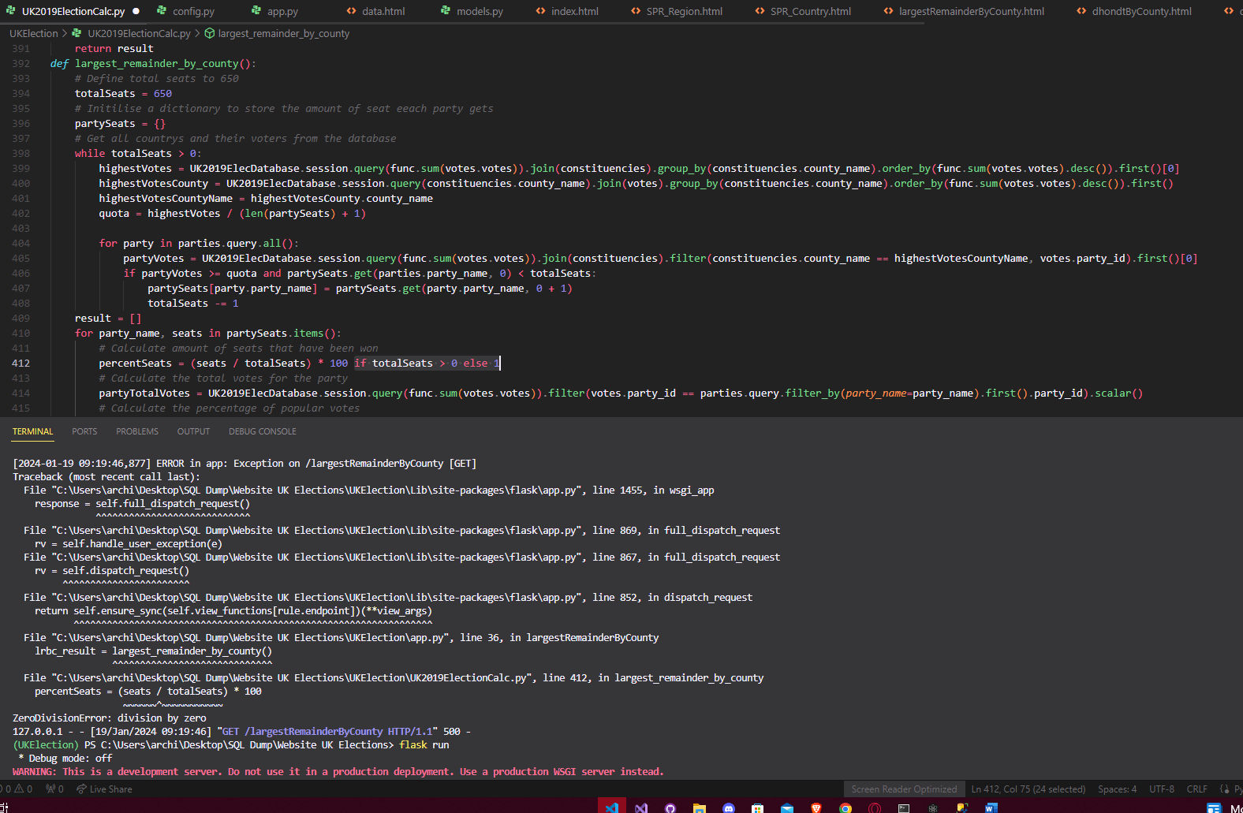
Data is probably wrong though:
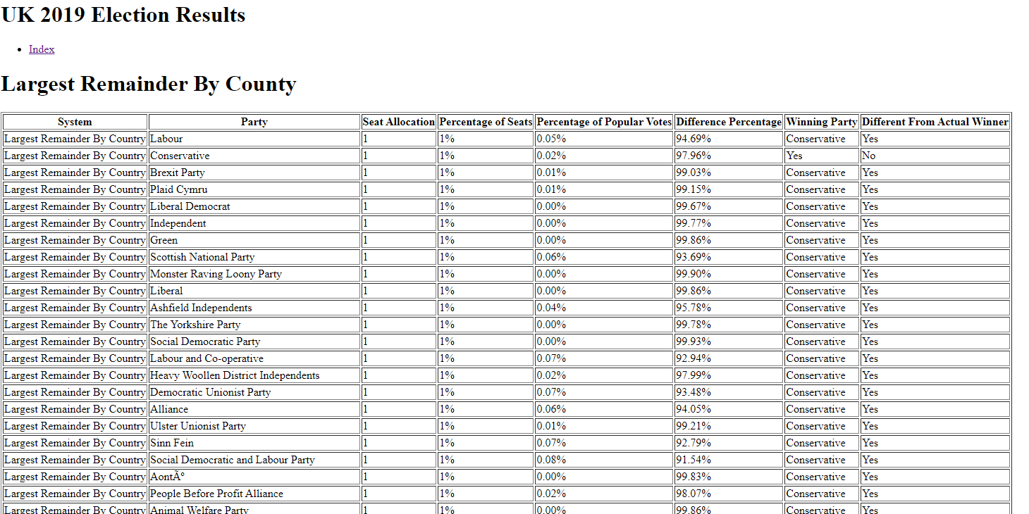
Fixing the code inside Largest remainder by region:
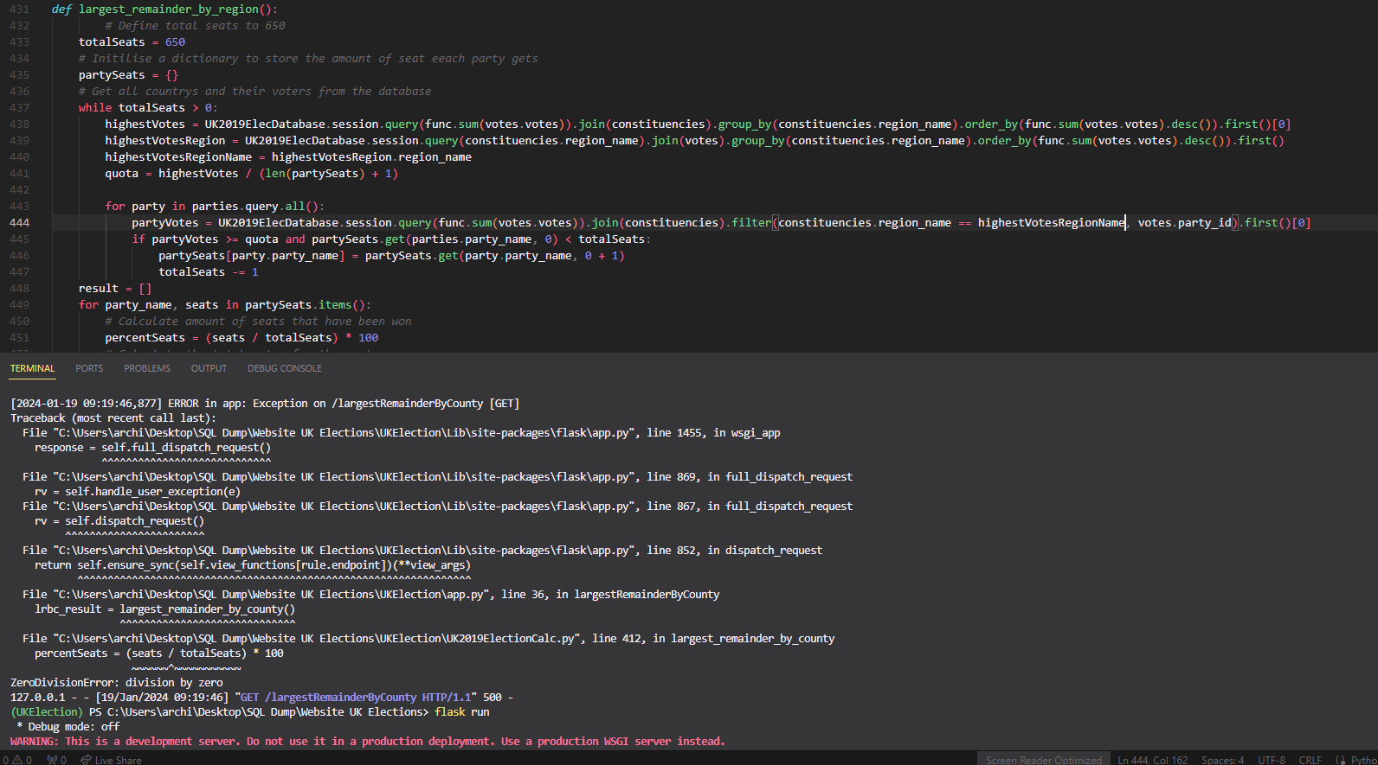
Now loads instead of internal server error
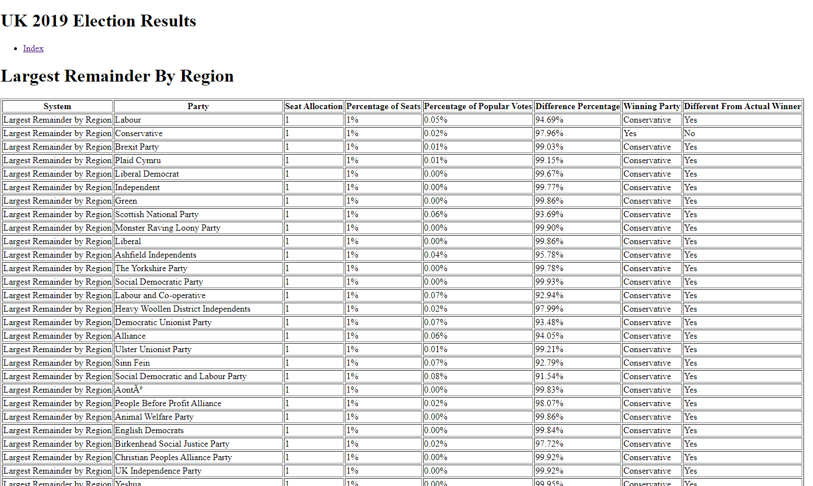
Fixing largest Remainder by country
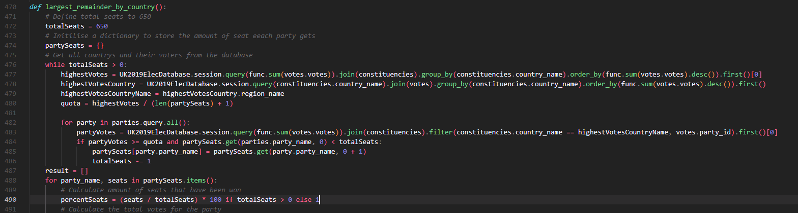
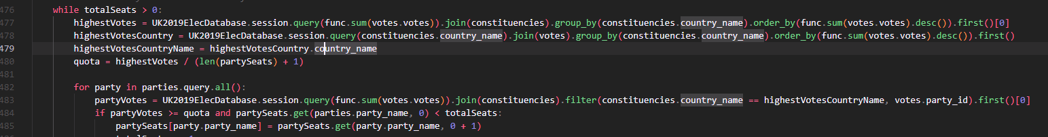
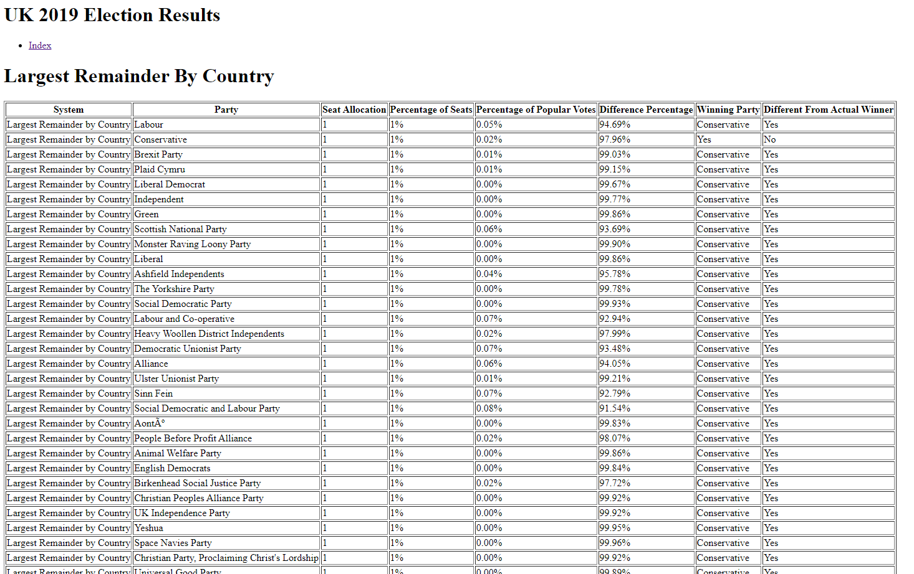

Table output of results:
Index page:
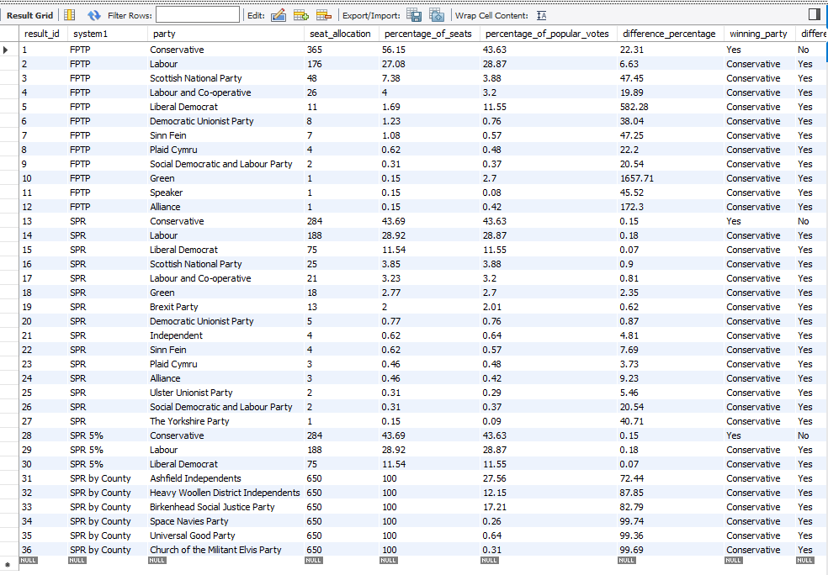
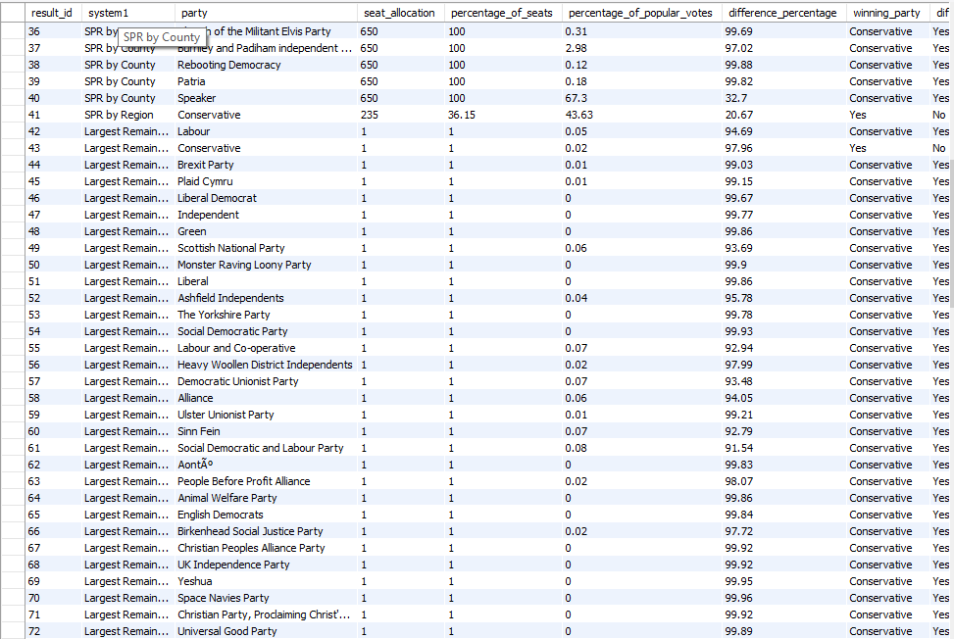
More from results table:
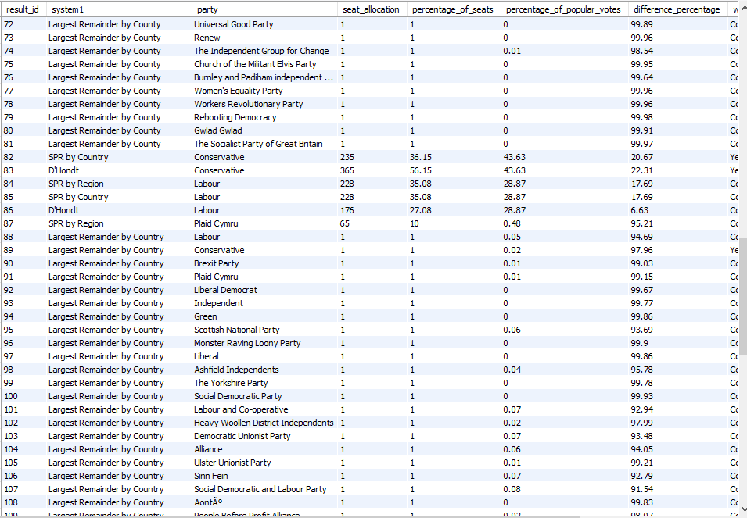
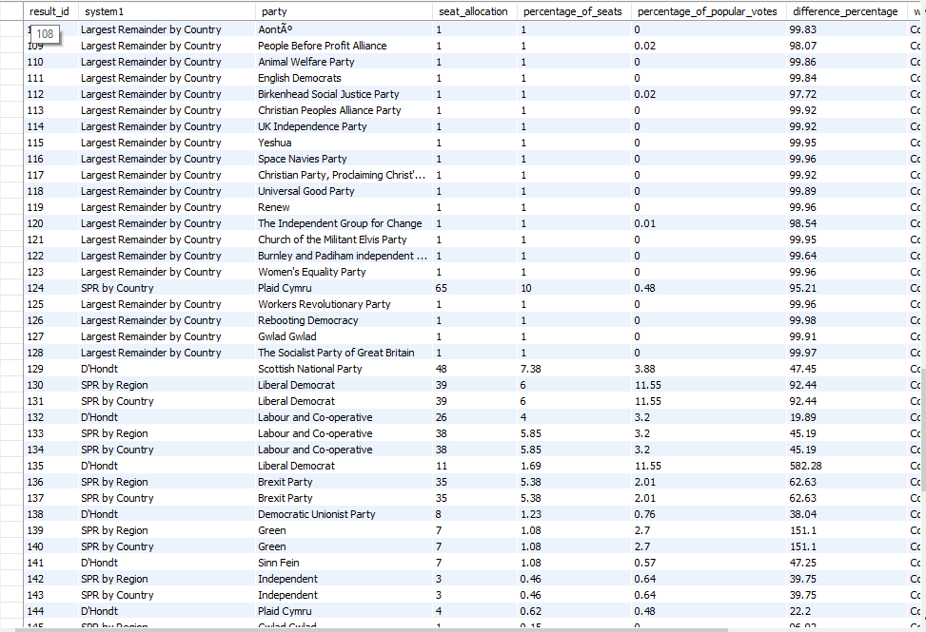
Mix of SPR:
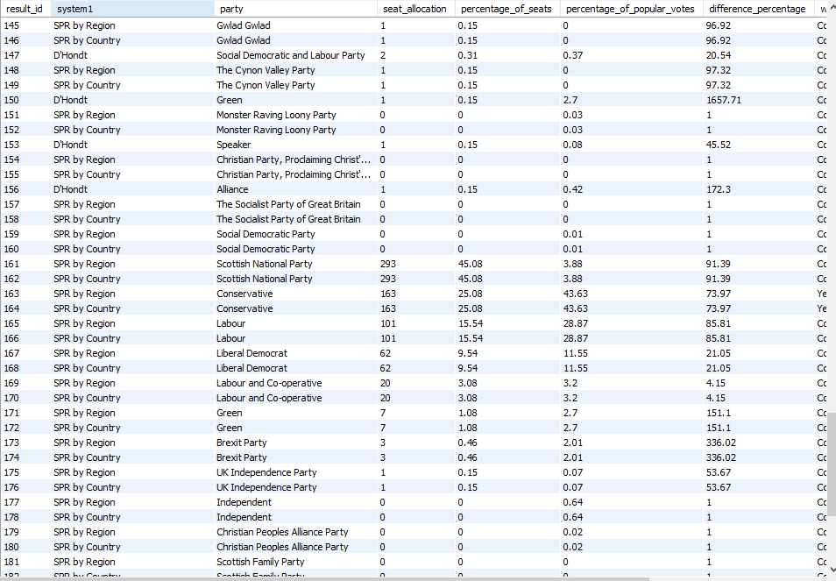
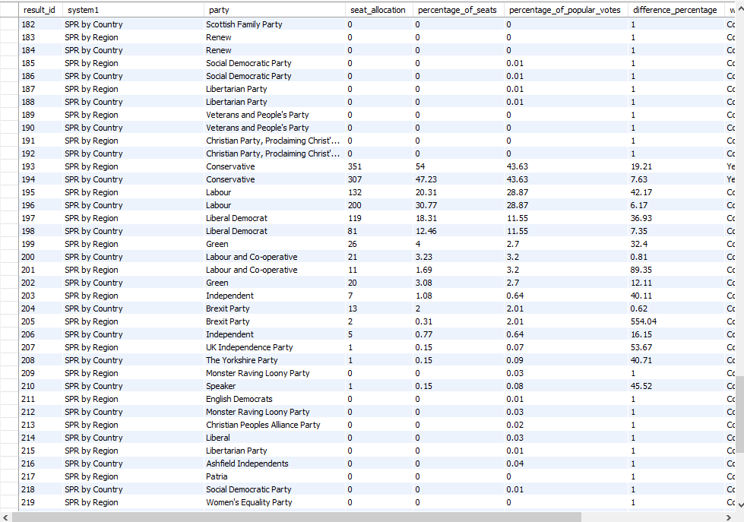
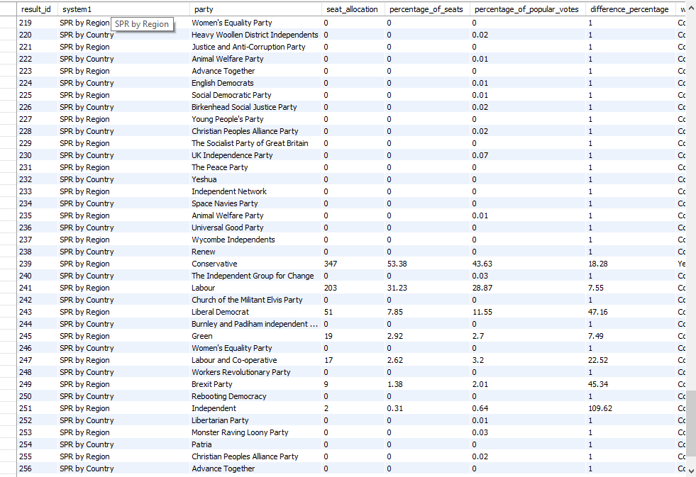
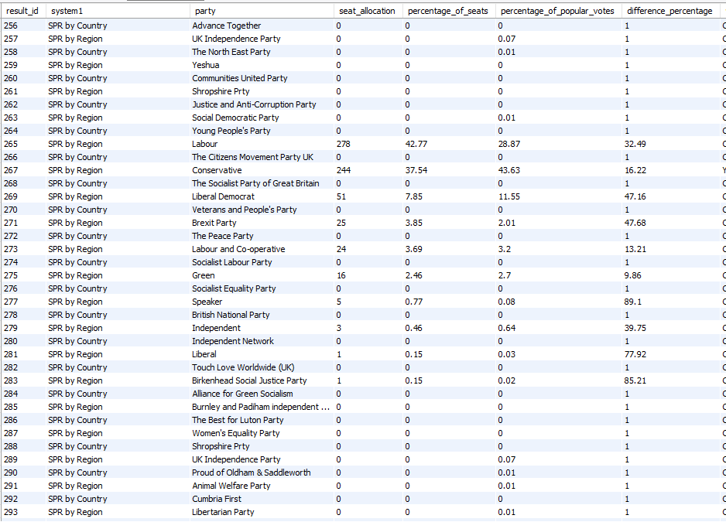
SPR region and country
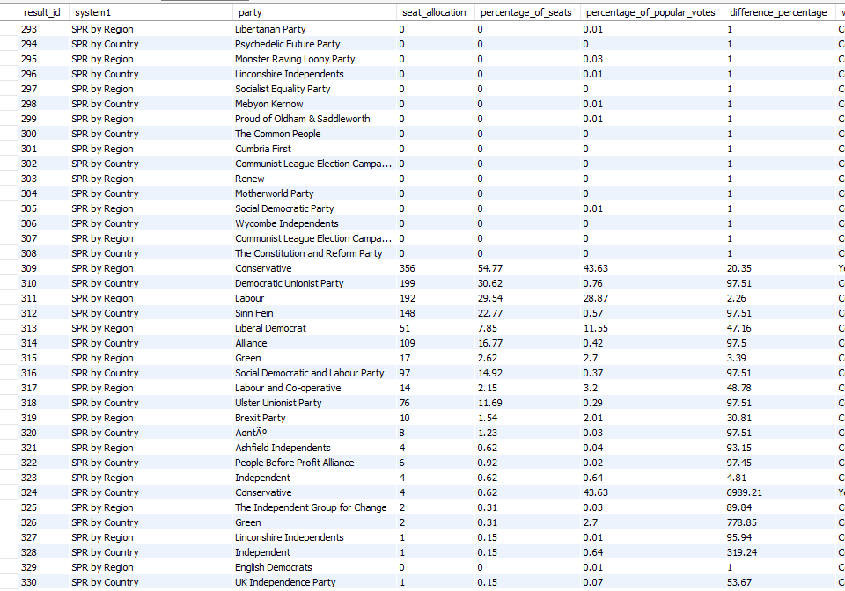

Different electoral systems from a mathematical perspective:
First Past The Post is a voting system where the party with the highest number of votes in a constituency is allocated all the votes for that constituency, regardless of if the vote split 51/49 or 100/0. FPTP doesn’t always provide a fair representation of the voters' preferences. Whereas Simple proportional representation aims to show the popular votes by allocating seats proportionally to the number of votes each party receives. (Mathlearningjourney, 2018)

References:
DigitalOcean (2021). How To Work with the Python Interactive Console | DigitalOcean. [online] www.digitalocean.com. Available at: https://www.digitalocean.com/community/tutorials/how-to-work-with-the-python-interactive-console [Accessed 17 Jan. 2024].
DigitalOcean (2022). How to Use Flask-SQLAlchemy to Interact with Databases in a Flask Application | DigitalOcean. [online] www.digitalocean.com. Available at: https://www.digitalocean.com/community/tutorials/how-to-use-flask-sqlalchemy-to-interact-with-databases-in-a-flask-application [Accessed 17 Jan. 2024].
DigitalOcean (2023). How To Query Tables and Paginate Data in Flask-SQLAlchemy | DigitalOcean. [online] www.digitalocean.com. Available at: https://www.digitalocean.com/community/tutorials/how-to-query-tables-and-paginate-data-in-flask-sqlalchemy [Accessed 17 Jan. 2024].
Mathlearningjourney (2018). Number Sense & Numeration: First Past the Post. [online] A Mathematics Learning Journey. Available at: https://mathlearningjourney.weebly.com/number-sense--numeration-first-past-the-post.html [Accessed 19 Jan. 2024].

Dyouri, A. (2020). How To Make a Web Application Using Flask in Python 3. [online] DigitalOcean. Available at: https://www.digitalocean.com/community/tutorials/how-to-make-a-web-application-using-flask-in-python-3 [Accessed 13 Jan. 2024].
freecodecamp (2023). Lambda Sorted in Python – How to Lambda Sort a List. [online] freeCodeCamp.org. Available at: https://www.freecodecamp.org/news/lambda-sort-list-in-python/ [Accessed 18 Jan. 2024].
freeCodeCamp.org (2018). How to build a web application using Flask and deploy it to the cloud. [online] freeCodeCamp.org. Available at: https://www.freecodecamp.org/news/how-to-build-a-web-application-using-flask-and-deploy-it-to-the-cloud-3551c985e492/ [Accessed 17 Jan. 2024].
GeeksforGeeks (2017a). Dictionary and counter in Python to find winner of election. [online] GeeksforGeeks. Available at: https://www.geeksforgeeks.org/dictionary-counter-python-find-winner-election/ [Accessed 17 Jan. 2024].
GeeksforGeeks (2017b). Find winner of an election where votes are represented as candidate names. [online] GeeksforGeeks. Available at: https://www.geeksforgeeks.org/find-winner-election-votes-represented-candidate-names/ [Accessed 17 Jan. 2024].
GeeksforGeeks (2018). Python | Introduction to Web development using Flask. [online] GeeksforGeeks. Available at: https://www.geeksforgeeks.org/python-introduction-to-web-development-using-flask/ [Accessed 11 Jan. 2024].
GeeksforGeeks (2021). Flask Rendering Templates. [online] GeeksforGeeks. Available at: https://www.geeksforgeeks.org/flask-rendering-templates/ [Accessed 18 Jan. 2024].
GeeksforGeeks (2023a). Declaring Models in Flask. [online] GeeksforGeeks. Available at: https://www.geeksforgeeks.org/declaring-models-in-flask/ [Accessed 18 Jan. 2024].
GeeksforGeeks (2023b). How to Run a Flask Application. [online] GeeksforGeeks. Available at: https://www.geeksforgeeks.org/how-to-run-a-flask-application/ [Accessed 18 Jan. 2024].
GeeksforGeeks (2023c). SQLAlchemy Core - Joins. [online] GeeksforGeeks. Available at: https://www.geeksforgeeks.org/sqlalchemy-core-joins/ [Accessed 17 Jan. 2024].
GeeksforGeeks (2024). Relationship Loading Techniques — SQLAlchemy 1.4 Documentation. [online] docs.sqlalchemy.org. Available at: https://docs.sqlalchemy.org/en/14/orm/loading_relationships.html [Accessed 18 Jan. 2024].
Macarty, M. (2020). How to Create a Database, Add Tables and Import Data in MySQL Workbench. YouTube. Available at: https://www.youtube.com/watch?v=OnXB3ZRrOW0 [Accessed 11 Jan. 2024].
MySQL (2024). MySQL :: MySQL 8.0 Reference Manual :: 13.1.20 CREATE TABLE Statement. [online] dev.mysql.com. Available at: https://dev.mysql.com/doc/refman/8.0/en/create-table.html [Accessed 18 Jan. 2024].
python.land (2023). Python venv: How To Create, Activate, Deactivate, And Delete. [online] Python Land. Available at: https://python.land/virtual-environments/virtualenv [Accessed 18 Jan. 2024].
RealPython (2020). Using the Python defaultdict Type for Handling Missing Keys – Real Python. [online] realpython.com. Available at: https://realpython.com/python-defaultdict/ [Accessed 18 Jan. 2024].
RealPython.com (2021). Python’s filter(): Extract Values From Iterables – Real Python. [online] realpython.com. Available at: https://realpython.com/python-filter-function/.
Ronacher, A. (2023). Flask: A simple framework for building complex web applications. [online] PyPI. Available at: https://pypi.org/project/Flask/ [Accessed 17 Jan. 2024].
S3CloudHub (2022). How to create a Simple Flask app in just 5 minutes | Python Flask Tutorial for beginners. [online] www.youtube.com. Available at: https://www.youtube.com/watch?v=6M3LzGmIAso [Accessed 13 Jan. 2024].
SQLAlchemy (2018). SQLAlchemy - The Database Toolkit for Python. [online] Sqlalchemy.org. Available at: https://www.sqlalchemy.org/ [Accessed 18 Jan. 2024].
SQLAlchemy (2024a). Configuring how Relationship Joins — SQLAlchemy 2.0 Documentation. [online] docs.sqlalchemy.org. Available at: https://docs.sqlalchemy.org/en/20/orm/join_conditions.html [Accessed 17 Jan. 2024].
SQLAlchemy (2024b). Error Messages — SQLAlchemy 2.0 Documentation. [online] docs.sqlalchemy.org. Available at: https://docs.sqlalchemy.org/en/20/errors.html [Accessed 17 Jan. 2024].
SQLAlchemy (2024c). ORM Querying Guide — SQLAlchemy 1.4 Documentation. [online] docs.sqlalchemy.org. Available at: https://docs.sqlalchemy.org/en/14/orm/queryguide.html [Accessed 18 Jan. 2024].
SQLAlchemy (2024d). Working with Engines and Connections — SQLAlchemy 2.0 Documentation. [online] docs.sqlalchemy.org. Available at: https://docs.sqlalchemy.org/en/20/core/connections.html [Accessed 18 Jan. 2024].
stackoverflow (2014). How to seat everyone according to preferences? [online] Stack Overflow. Available at: https://stackoverflow.com/questions/20832994/how-to-seat-everyone-according-to-preferences [Accessed 17 Jan. 2024].
SQLAlchemy (2010). Declaring Models — Flask-SQLAlchemy Documentation (2.x). [online] flask-sqlalchemy.palletsprojects.com. Available at: https://flask-sqlalchemy.palletsprojects.com/en/2.x/models/ [Accessed 19 Jan. 2024].

stackoverflow (2017). Listing table results to HTML with Flask. [online] Stack Overflow. Available at: https://stackoverflow.com/questions/43863584/listing-table-results-to-html-with-flask [Accessed 17 Jan. 2024].
Todd Birchard (2018). The Art of Routing in Flask. [online] Hackers and Slackers. Available at: https://hackersandslackers.com/flask-routes/ [Accessed 18 Jan. 2024].
w3schools (2019). Python MySQL. [online] W3schools.com. Available at: https://www.w3schools.com/python/python_mysql_getstarted.asp [Accessed 13 Jan. 2024].
WilliamDAssafMSFT (2023). Create Foreign Key Relationships - SQL Server. [online] learn.microsoft.com. Available at: https://learn.microsoft.com/en-us/sql/relational-databases/tables/create-foreign-key-relationships?view=sql-server-ver16 [Accessed 18 Jan. 2024].
freecodecamp.org (2022). TypeError: module object is not callable [Python Error Solved]. [online] freeCodeCamp.org. Available at: https://www.freecodecamp.org/news/typeerror-module-object-is-not-callable-python-error-solved/#:~:text=To%20put%20it%20simply%2C%20the [Accessed 19 Jan. 2024].

